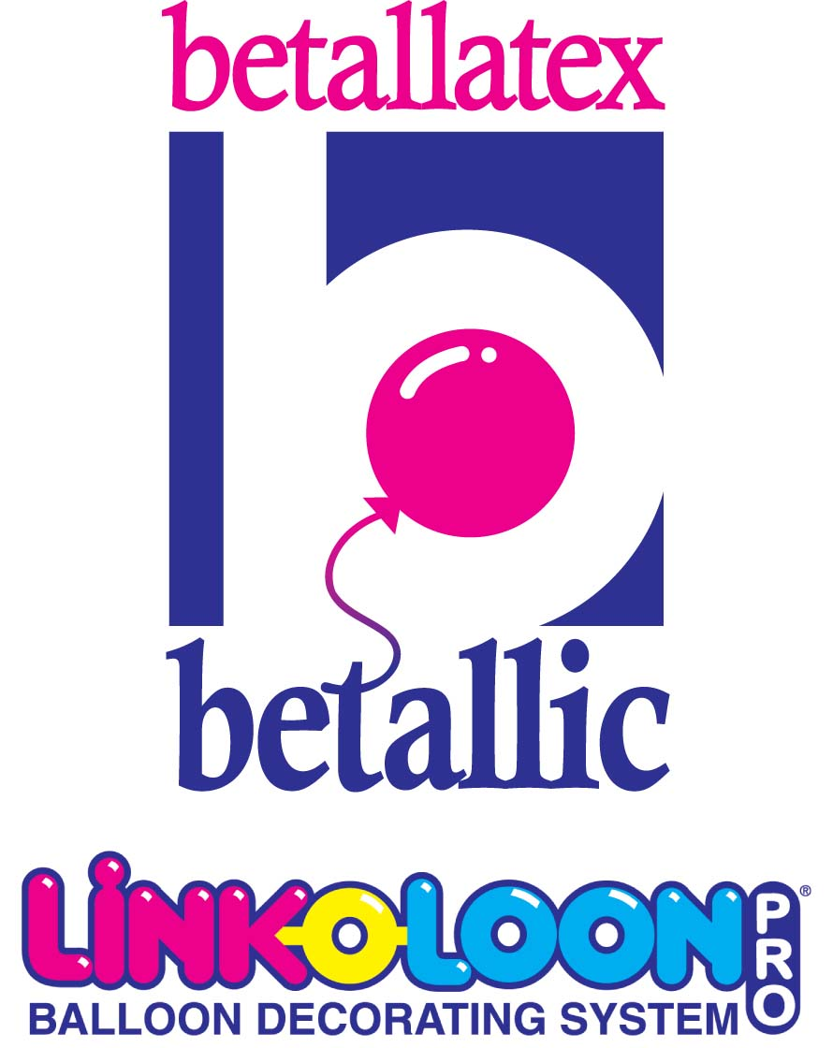
Pretty and Profitable


By Jan Iiams, CBA – Betallic Education Director

LINK-O-LOON® are easy to use and perfect for beginners AND veteran balloon artists. Even inexperienced customers are able to create classic décor faster and more precisely with professional appearance, while advanced artists are able to create décor designs that will set them apart in more creative ways from competitors.

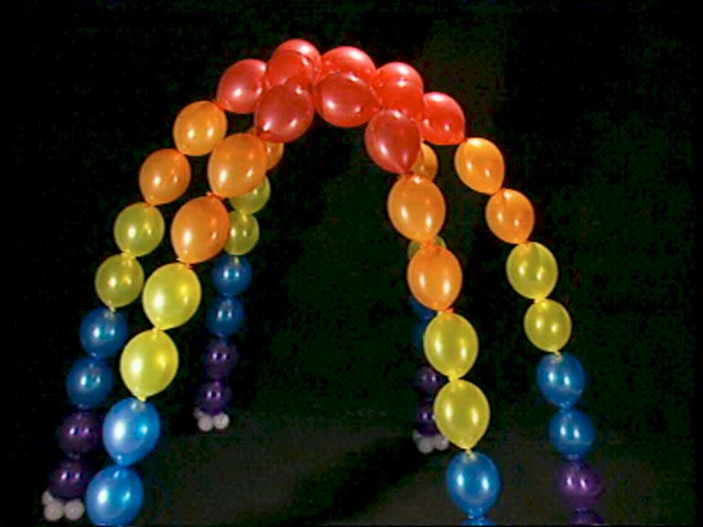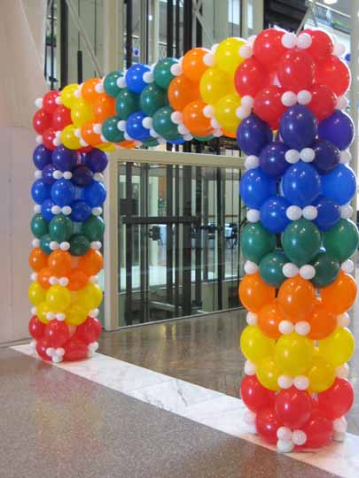
Beginner Advanced
Sean & Edelgaurd O’Kelley, CBAs A Eddie Heyland, Balloon City USA

6” and 12” sizes work similarly with great opportunity to use the smaller size LINK-O-LOON® in more than standard décor settings. Tethering Holographic foil shapes and helium latex works well for creative bouquet and centerpiece use as well and make you look more creative.

The no-tangle benefit is a huge plus for delivery and carry out designs, columns and arches.
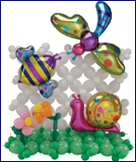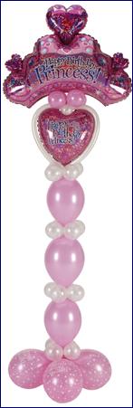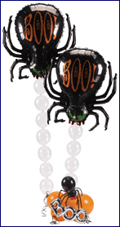
Designs by Jan Iiams CBA, Betallic

You will love to the ability to create a wider variety of décor projects with bigger design impact than in standard round balloon techniques which often takes more balloons. This means you can offer more décor for your customer’s budget. There is less labor and LINK-O-LOON® fill more space which awards more profit.

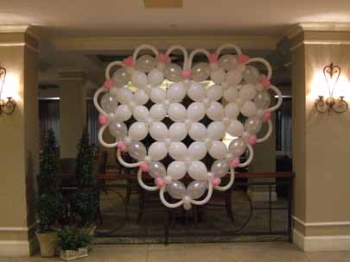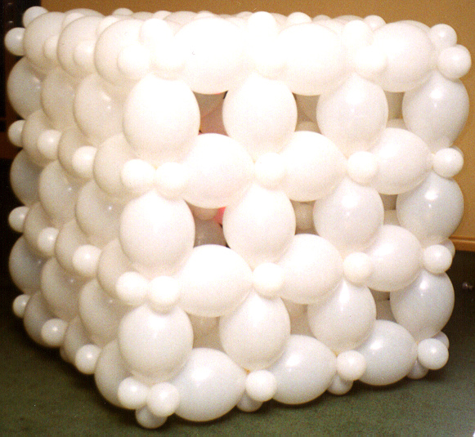
Linda Kiss, CBA Balloon Decorating.com Guido Verhoef, CBA Manifold Netherlands

LINK-O-LOON® offer more opportunity to forgo base plates and poles and other frames. This means no expensive return trips after event strike, fast teardown when needed and no lost equipment to replace.

They afford artists fast and more efficient techniques and many more options with air or helium for column based decor. There are chain style columns, designs that replace traditional garland columns with other techniques that stand alone, impressive covers for pillars or poles and amazing variety for more advanced accents and special effect for columns.

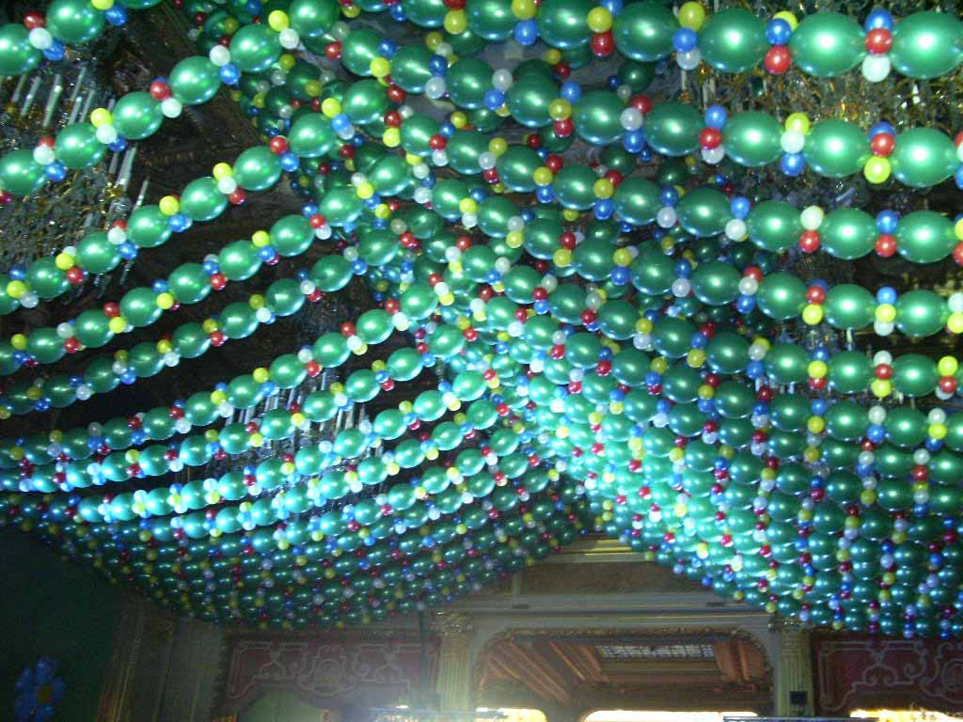
Bidou, Paris

LINK-O-LOON® is easy to measure. From tip to neck it is 12” and in the smaller size, 6” for easy determination of how many are needed to fill a specific space. Arches can be simple to impressive with LINK-O-LOON® so artists will have many more options to offer their customers. Simple LINK-O-LOON® chain arches can be transformed into more with small air filled collars, by combining two arches into a lattice, by combining a series into a tunnel, backdrop, wall covering or canopy.

For easy to follow lessons to create LINK-O-LOON® décor, go to www.betallic.com and check out hundreds of bdecor recipes in a wide variety of seasons, themes and occasions.

Happy Designing!
Jan

