
The Art of Air-
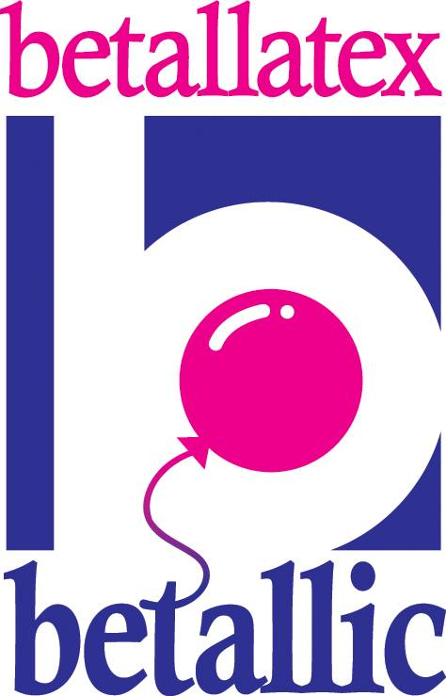

Filled Arrangements

By Jan Iiams CBA, Betallic

You can build a huge variety of showcase designs using LINK-O-LOON®, rounds, and non-rounds on frames. For smaller arrangements, use Lomey, balloon straws and cups, a few special adhesive tricks and other easy to use frames and bases as the intrastructure. Add beautiful accents and elements to create the dressing that will entice your customers and help you create signature designs for your company.

The three secrets to your success in creating air filled designs are:
- Mechanically Sound – Air filled arrangements are designed to stay together all the way from your shop to the venue and look just as beautiful as when you first finished constructing it.
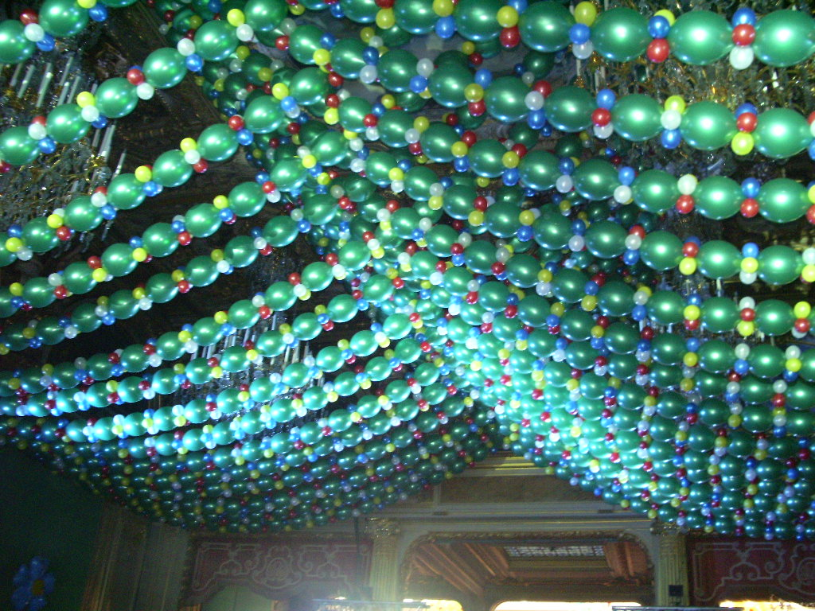
- Strong Design – If it’s eye catching, everyone will notice. There’s no better way to formulate and build a beautiful design than to know the Principles and Elements of design.
- Consistent Sizing – use precision inflators that auto size your balloons or use a sizing template. I recommend a Conwin Precision Plus and Clik-Clik™ Slide-N-Size template for regular inflators.
Bidou – Paris, France

LINK-O-LOON® are one of my favorite methods to fill a large space creatively and without spending a lot on labor or the product. On the b Gallery at www.Betallic.com there are many designs from large to small, from simple to spectacular using air filled LINK-O-LOON® elements in the designs.
All air filled designs have at least a few things in common, but you can easily achieve a variety of looks with the following applications…

- LINK-O-LOON® backdrops on base plates and poles or suspended from ceilings with Clik-Clik™ Mag Movers appear to be floating in air.



- A topiary design using a 12-balloon cluster must all be sized precisely
to insure the topiary top is perfectly round and that the balloons fit
closely together.
- A dainty arrangement that spirals undersized 5 inch balloons in progressive sizes is visually more interesting and pulls the eye from the base, up through the arrangement to the accent at the top of the design.
- A whimsical arrangement with a rose blossom inside a clear balloon creates a focal point with a touch of magic. Your customer may ask, “How did you do that?” It’s simple-- but we don’t let your customers know the secret—pre-stretch the balloon to make it easier to insert the blossom by hand. The Lomey is of most importance to build this type of design, but visually is of least importance.
- Columns in any size give you an opportunity to showcase special effects in your designs. Lights, garland, shred and HI-FLOAT® with glitter can be inserted in the column for enhanced visual worth in your centerpiece work.

A few final air filled design tips…
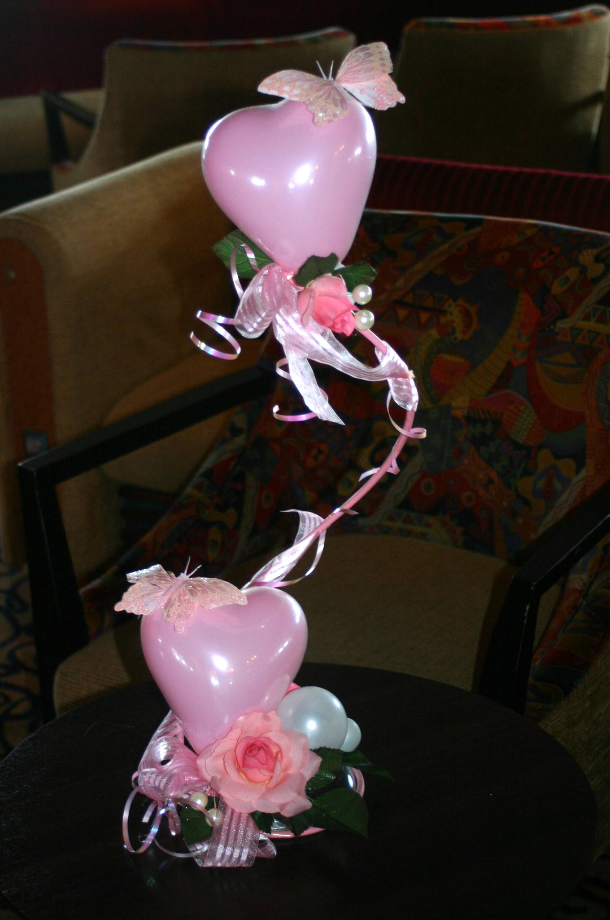
- Designs can be symmetrical or asymmetrical
- Balance is extremely important. A large topiary top for instance with a skimpy base will be top heavy. Add a few well-placed elements at the bottom to balance the look.
- Adding ribbon tendrils or placement of accents that lead the eye through the arrangement is necessary to add rhythm and motion to Lomey pedestal designs to connect the most important elements together.
- You’ll make more money with high-perceived value and labor saving air filled designs.

See you online!
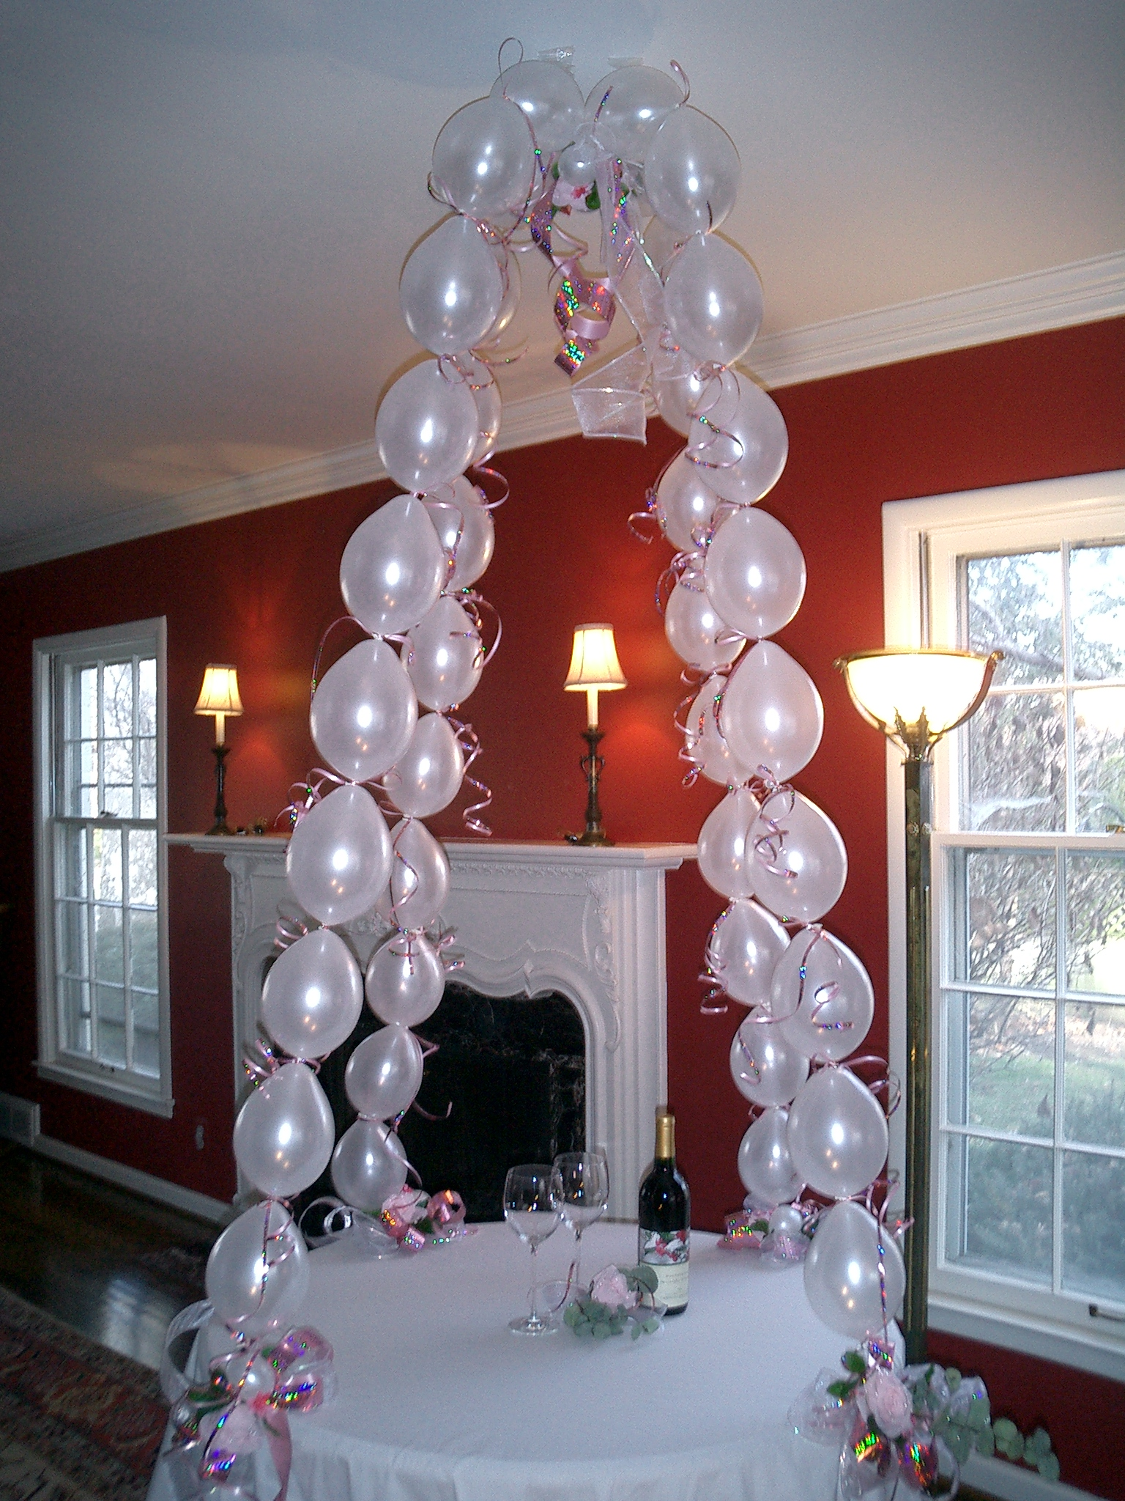
Jan Iiams, CBA
Betallic LLC
www.betallic.com

Concept by Robina Bernard, Clik-Clik™
