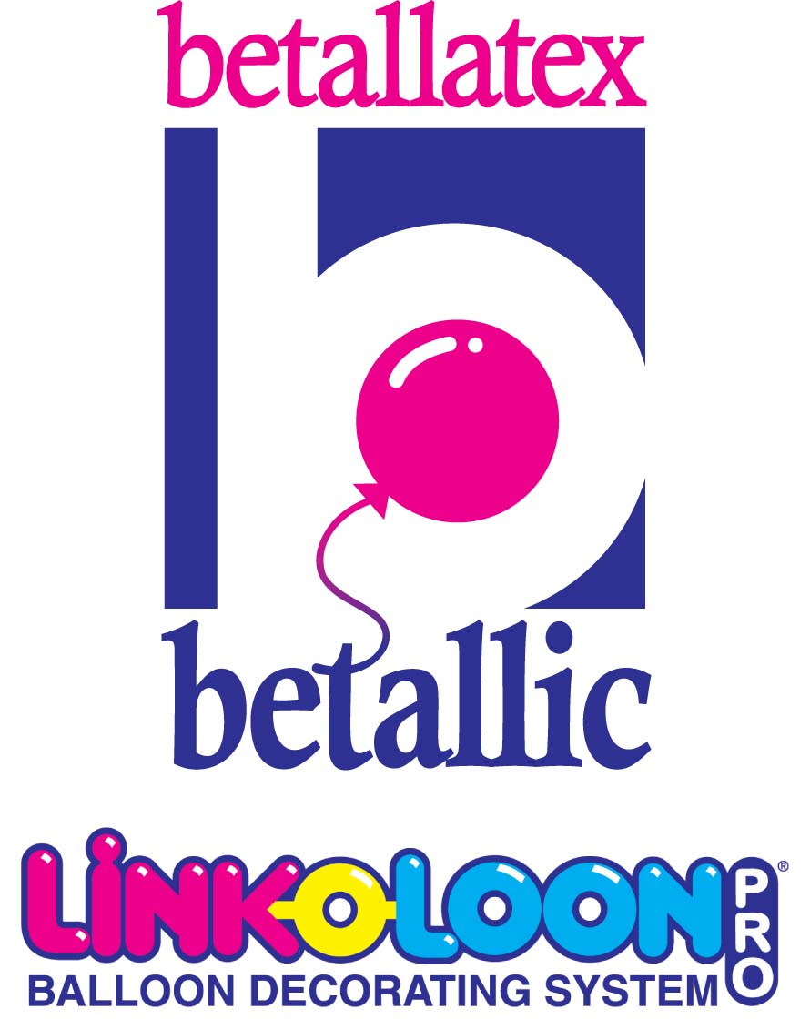
The Budget Bride… 
Your bridal customer wants
you to create something beautiful for her reception for how much???

It’s a big challenge to create something for bridal customers who aren’t “in the know” about the creative
possibilities that you can offer with balloon decor for their wedding reception and even worse, who have tiny little budgets.

Three balloons on a sandbag is just plain boring and does nothing for your creative reputation. After all, the bride’s friends could be your next customer if they’re impressed with your work.

Following are a few tips to expand your artistic options when there are financial limitations:

- Every other table—this means making something lovely
for every other table instead of something unimpressive on
every single one. A simple element from the centerpiece can
look wonderfully dainty and harmonious when placed on
the remaining tables. An example might be an air filled 6 inch Betallatex latex heart with a “gem” or flat sided marble or
two inside for weight that positions the balloon at an artistic
angle. Tie a simple but pretty bow onto the neck letting the tails tendril onto the table, then to finish you might add a small silk bud to the bow and viola! It’s an adorable accent centerpiece that compliments the larger more impressive designs.
- Double Bubble Centerpiece—What? Double Bubbles
are more expensive than a regular balloon when
constructed with an 11 inch inside of a 18 inch balloon.
However, making a single Double Bubble balloon with
the brides color of choice inside, then dressing it with
inexpensive accents and a pretty tie down can make a
beautiful centerpiece all by itself.
Tip: Use wider ribbon than the standard 3/16 inch curling
ribbon to insure the elements are in balance with each other.
There are many ribbons in #9 and #40 sizes that are relatively inexpensive but that add substantial visual worth to a design
far beyond the actual cost.
- Canopy Options —It doesn’t have to be a full canopy…
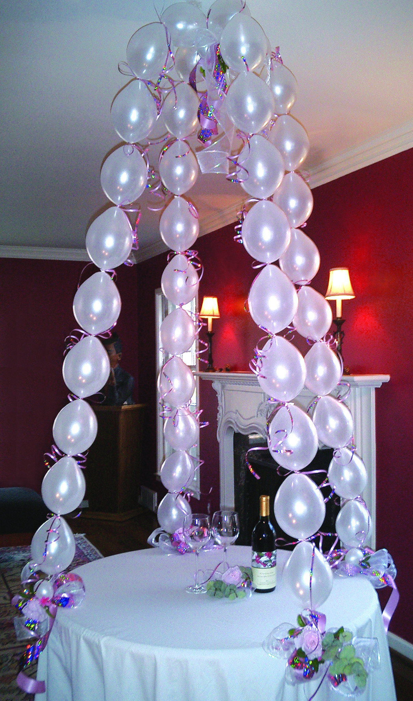
LINK-O-LOON® make beautiful yet simple criss cross coverage possible. Consider covering the poles with 260s inflated, tied into clusters then swirled and secured onto the poles to cover instead of 11 inch garland. A lighter touch can be lovely! Betallatex latex are all perfectly color matched: rounds, non-rounds and LINK-O-LOON® for a color palette your customers will fall in love with.
- Swags—Ceiling treatments are simple with air-filled
LINK-O-LOON® swags. Cross them, drape them; connect them to helium clusters for fast and beautiful coverage over a dance floor.
- Gazebo—Wow, in the following gazebo picture look at
what you can make with the simplest of elements! The cost to assemble this easy-to-do design is about $5 including the ribbon and
inexpensive silk flowers. Perfect for the cake table, gift table or even to decorate the head table—fast, easy and the perceived value is through the roof!

What a beautiful way to exceed the expectations of a customer with a small budget but that still allows you to make a very healthy profit margin beyond typical décor options.


Good Designing!
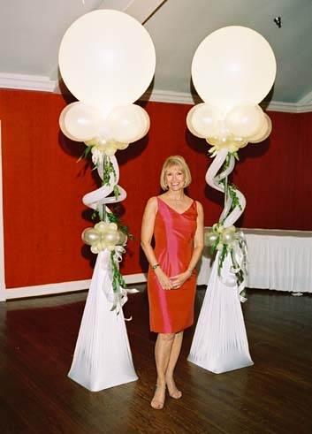
Jan Iiams, CBA
Betallatex Creative &
Educational Manager

