



Jan Iiams, CBA - Creative and Education Director - Betallic LLC

Special Effects with HI-FLOAT®

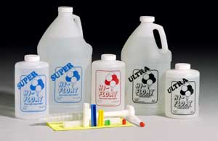

With ULTRA HI-FLOAT® and Betallatex Balloons, you can create dazzling, long lasting arrangements that will expand your design repertoire in a dramatic display to show and sell. For real magic, simply add a few creative accessories and you’ll command the attention of customers who are looking for trend setting designs and who are willing to pay for it.

Boost your sales and your profits with ULTRA HI-FLOAT® balloon treatment. This revolutionary liquid makes latex balloons float approximately as long as foil balloons! Following are a few tips to make your balloons last longer with ULTRA HI-FLOAT® inside…

- Always fill latex balloons fully to increase float days. As long as the ULTRA HI-FLOAT® is wet, it continues to allow helium to pass through the surface of the balloon and shrink. Only when the HI-FLOAT® is dry does it capture the remaining helium and then allows latex balloons to float much, much longer.

- Make sure the ULTRA HI-FLOAT® coating covers the entire inside surface of the balloon up to the area where you will tie the neck.

- When using pearl and metallic latex, it really does make them float a little longer if you inject ULTRA HI-FLOAT® into the balloon, rub it around the inside a little, and place a rubber band around the necks of several balloons you treated in this manner. The following day, they can be massaged to re-coat the interior evenly, inflated and they will float longer than if treated and inflated immediately. Or, pre-inflate the balloon to stretch it and then treat with ULTRA HI-FLOAT® and inflate with helium. This is especially helpful when using treating Betallatex metallic and pearl LINK-O-LOON® to add more float time than if not pre-stretched.

- Always use the proper restriction clip. If you guess at how much to use, your results will vary. If you use less than the correct amount the balloons will float for a shorter time. Remember, ULTRA HI-FLOAT® requires less solution than previous formulas and is lighter and dries faster! Check the information in your kit to use the proper size restriction clip.

- The Dry Method: To greatly increase the float time of a treated latex balloon, treat the balloon and inflate it. Wait about three to four hours for the HI-FLOAT® to dry, and then reopen the neck of the balloon without releasing any helium and add enough helium to replace the helium that was lost during drying time. It’s amazing! This method is most appropriate for merchandising displays and for décor that must last an extremely long time.

Oxidization is a battle we face often when transparent balloons become cloudy looking. When you need a crystal clear finish that lasts longer than simpler treatments like balloon shine chemicals, there are two methods that performs more effectively but with a bit more time and effort on your part.

- The Pouring Method is for balloons that have already been inflated like Classy Wrap, with gifts enclosed in a large 18” Betallatex crystal clear balloon. Gently but thoroughly mix 1 part water to 2 parts HI-FLOAT® in a paint roller pan or other large container, and then pour the solution over the balloon surface to coat it completely. Hang the balloon over newspaper to dry which takes about one half hour for a beautiful, glassy finish!

- The Dipping Method is for balloons that have not been inflated yet. Place a straw into the balloon before dipping it into undiluted HI-FLOAT®, allowing the excess to drip off and then inflating. This method only takes a few minutes to dry.

To add confetti and special glitters as an enhancement inside or out there are a few points that will insure your success every time…
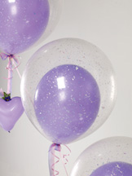

Inside:
- Keep the ULTRA HI-FLOAT® coating from the lip of
the balloon. It should coat the inside up to where
you will tie the neck. Confetti won’t fall down into
the balloon easily if there’s too much HI-FLOAT® at
the edge of the opening.

- I don’t use a funnel to place confetti inside the balloon;
my favorite method is to drop it into the neck by hand.
For an 11-inch balloon you need about 1 teaspoon of
confetti, for an 18 inch balloon, about 1 tablespoon for
good coverage.

- After the confetti is in the balloon NEVER rub the confetti.
Pinch the neck of the balloon and shake it to coat the inside of the balloon and then inflate it quickly.

- Always use glitter that doesn’t have sharp edges on the inside of balloons. Sharp edges can make the balloon pop!

- Wear eye protection when inflating confetti balloons. If it pops, it won’t get in your eyes.
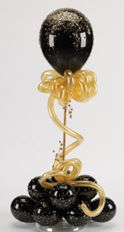

Outside:
- After dipping balloons into HI-FLOAT®, confetti can
be applied by rolling the balloon in confetti and
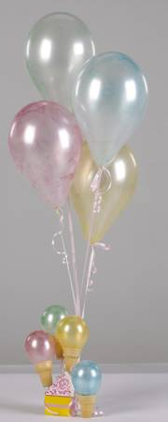
then inflating, or inflate it first and apply the confetti
by hand in a planned pattern.

Other special effects tips:
- Food Coloring inside balloons are a beautiful way to
add color and texture to balloons of any size.

- Painting HI-FLOAT® in patterns on balloons and then
adding glitter to the wet surface will allow you to make
one-of-a-kind designer balloons.

- I make extra speedy Spider webs by using the dipping
method, partially inflating the balloon and then when dry,
turning the balloon inside out before inflating.
This methods works in a few hours instead of overnight.

Finally, your first few balloons may leave you with sticky fingers. However, with practice your work with ULTRA HI-FLOAT® will be faster, easier, tidier, and best of all… more profitable!

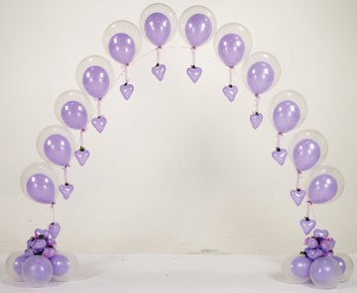

For additional information on other creative uses and
techniques for designing with HI-FLOAT®, go to www.Hi-Float.com
for inspiration.

For step-by-step instructions to create amazing balloon décor,
visit www.betallic.com and register for bGallery to view designs
and follow directions for a huge selections of themes and occasions
including designs based on HI-FLOAT® techniques.

Below is a clip-and-keep chart with float time, number of treatments, and balloon type performance that I know you’ll find helpful when planning projects and determining costs.
FLOATING LIFE
ULTRA HI-FLOAT® increases floating life by about 25 times. The following table shows typical floating times for various sizes of Betallatex balloons:
Betallatex  Balloon  Size | Betallatex  Balloon  Type | Average  Flying Time  Helium Only* | Average  Flying Time  Helium and  ULTRA HI-FLOAT® *
11” | STANDARD & CRYSTAL ROUND | 12-24 hrs. | 1-4 weeks
11” | METALLIC &  PEARL ROUND | 12-24 hrs. | 1-3 weeks
12”” | STANDARD & CRYSTAL  LINK-O-LOON® | 12-24 hrs | 1-3 weeks
12” | METALLIC & PEARL  LINK-O-LOON® | 12-24 hrs | 1-3 weeks
18” | ROUND | 36+ hrs. | 3-6 weeks
16” | HEART | 14 hrs. | 3-5 weeks
3’ | GIANT | 3-5 days | 4-16 weeks
Please remember that these are estimates based on typical indoor conditions and following all of the instructions at www.hi-float.com. Flying time will be less if outdoors. Flying time varies greatly due to factors such as humidity, temperature, altitude, etc. Balloons typically float for less time in hot, humid weather.
For pearlized or metallic balloons you must pre-stretch the balloons with air before treating with ULTRA HI-FLOAT® and inflating with helium. Pre-stretching allows you to inflate the balloons to a larger size and achieve the float life listed in the table above.

