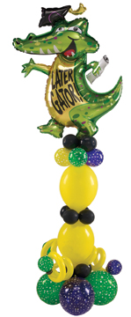
Money Saving Tricks

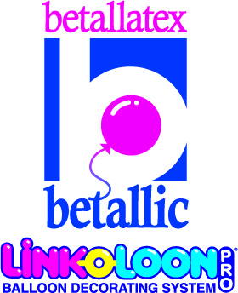
By Jan Iiams, CBA
Betallic LLC

Balloons are very much like high tech greeting cards. They evoke emotion with color and design and express feelings in the magic of a lighter than air message. Balloons bring out the kid in people of all ages and are a delightful way to increase your average sale amount on a daily basis.
Betallic Holographic foils and Betallatex latex balloons are an easy and beautiful way to elevate your profits, build relationships with your customers and enhance profit making skills.
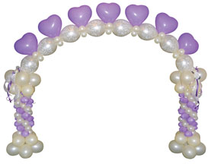
Here are some great tips from industry experts that will streamline your efforts and keep you current with trends in purchasing, inventory, inflation, training and display, even if you’re a balloon veteran or a new artist in our creative industry.

Purchasing Power:
Today’s smart buyer wants to save time and money. Many wholesale distributors have a presence on the web as well as full-line catalogs. For special sales and the new products they offer, check distributor web sites for fast information and easy ordering at virtually any time, day or night.
For distributor referrals and to see the very newest products being unveiled, check manufacturer web sites. Many manufacturer sites such as Betallic.com, Hi-Float.com, MagMover.com, Conwinonline.com, and more also offer educational information on their products and excellent design instruction.
Today the best technique for ordering efficiently and getting the most value for your money is to order more but less often. You’ll save on shipping costs and many distributors offer freight incentives and discounts for orders placed in quantity. Check with your distributor about their volume discount criteria. You’ll find that many now allow you to add smaller quantities of items together to achieve a volume discount.


Intelligent Inventory :

The ideal inventory would be having just one of every item left on the shelf just as your order arrives to assure you that you hadn’t missed a single sale. Since that is just a wish and not a reality, you’ll find the following tips will help you inventory smarter.
Spinner racks are one of the most efficient ways to store your inventory. Although they were initially introduced and work well for display purposes, some busy companies are now using the spinner rack as storage for their balloon inventory. At a quick glance, you can see what items are low without digging through drawers, files or shelves that often damage balloons to see what’s due for reorder.
Don’t get into an inventory rut. Your repeat customers love to see new things, and there’s nothing like a beautiful new balloon pattern to inspire your staff’s creativity. Note which patterns are your best sellers and which ones you can afford to change out periodically or seasonally to keep a fresh look to what you sell.

Step up to Holographic and Step up to brilliant latex colors without paying premium prices:
Betallic foils are now in a sparkling Holographic finish for a more impressive impact in foil message balloons and you will love the prices; why pay the same for standard foils that have been around for decades? Betallatex latex rounds, hearts, LINK-O-LOON® and 60s series are a

beautiful way to add creativity and signature accents to
your designs. Keep a variety on hand for inexpensive
yet impressive add-ons that set you apart.

Display Today:
The most visually impressive trend today for showing your selection of foil balloons is to display air filled balloons on the wall near your service center. Foil balloons are designed to look most impressive when inflated. Stands that show each balloon flat, on a plastic covered page similar to a flip chart is a very dated display method that doesn’t show balloons at their best and requires more expensive time from the sales person.
Betallic spinner racks as mentioned above are a great way to display your balloons. Retail customers shop for them in the same way they shop for a greeting card. Because the spinner rack inventory is packaged, product stays clean and fingerprint free, and it doesn’t require a sales person to “babysit” the customer through the entire sale. The small extra cost for packaged balloons more than makes up for the labor costs involved with older display methods, and the rack takes up a minimum of expensive retail floor space.

Easy and Efficient Inflation:
Things have changed! At one time everyone had a simple tank and tilt valve filler valve to inflate balloons with. Today, there are a myriad of choices for equipment to make your balloon work a breeze and substantially more profitable.
There are so many great inflators to choose from now and even the simplest ones are so much better than the old days.
With new FAST FLOAT™ pre-treated latex, a push valve inflator makes filling HI-FLOAT® treated latex cleaner, faster and consistent. Go to www.betallic.com for a short video of details on the product and inflators.
Today’s inflators almost always include an auto-shutoff valve to insure foil balloons are filled fully but not over-inflated. This money-saver means less poppage of foil balloons. For shapes and extra large foils, stop inflating just before the inflator does the job. The calibration is set for auto-shut off inflators for 18” hearts and rounds and with shapes and large size foils, they can over-inflate if you push the inflation all the way until the inflator stops automatically.

Service Center:
Here are a few items that are simply a must for an up-to-date workspace so that your staff can create professional balloon arrangements.
- ULTRA HI-FLOAT® for long lasting latex balloons. Your customers will love you for it and your competition is using it.
- Ribbon in a variety of colors. Tie on two colors for an incredibly inexpensive way to increase perceived value of your balloons.
- Professional equipment, tools and displays insure your staff can work faster and their work will look more polished. Don’t skimp on these one time purchases. The best is simply the best!

Techno Training:
Training new staff used to take days or weeks and mistakes were costly. There is excellent training available online today. What a great way to train new staff—show them how to find and follow step-by-step bdecor recipes at www.betallic.com.

Final tips:
Safety is not only important, it’s the law. Portable safety stands are much safer and appear more appropriate to a retail setting than hooks in the walls for chaining helium tanks to secure them.
Finally, you have so many more choices today than in past years as you can see from the suggestions here. Check industry marketing materials, and look at manufacturer’s magazine ads and web sites to find the products that will increase your sales and make your shop more inviting and your work more beautiful.

Wishing you Success,
Jan Iiams, CBA

