Let Betallic
Balloons Inspire Your
Creativity!

By Jan Iiams, CBA
Betallic Education Director
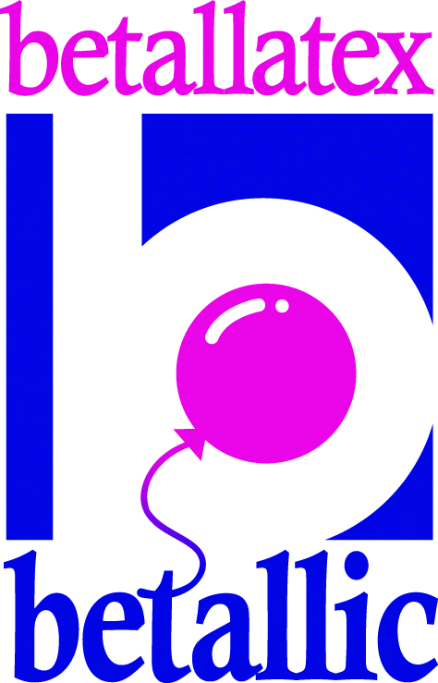

From Simple to Simply Spectacular…be creative!

You can stack ‘em, overlap em’, or get creative in their placement to make a typical balloon design more enticing and interesting with Betallic’s beautiful latex balloon line.. You can use imaginative color placement and step up the size and shape of balloons to increase the visual appeal of the most ordinary of designs, adding very little to the cost, but definitely adding perceived value to your work.

The amazing quality of this line of balloons including LINK-O-LOON®, rounds and non-round balloons, are in more colors and sizes than ever before. This allows you to offer more creative options for expanding your design repertoire will enhance your artistic reputation and make your work easier and more profitable.

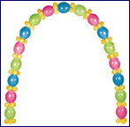

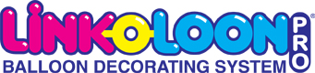

Be a pro…
Using the proper terminology can instill confidence in your client. Just like using the word “monofilament” instead of “fishing line”…you just sound better! Your customer may not know exactly why your work looks so wonderful, but they will recognize well-designed décor when you show it to them. Let’s learn how to make your work it’s best with a quick review of “the rules” that govern design of all kinds.

- Unity is the relation of elements in a design to create a look of “oneness”.
- Proportion and Scale is referring to the design elements and how they relate to each other.
- Focal Point is the center of interest. Typically the largest or darkest element placed low in the design.
- Accent is secondary to the focal point but adds emphasis.
- Balance of elements physically and visually within the design.
- Texture is the surface quality of a shape - rough, smooth, soft hard glossy etc. Make your design more interesting with a pleasing mix of coordinating elements.
- Harmony The elements must compliment each other.
- Rhythm leads a visual path through the design.
- Space is needed to allow elements to stand apart to be seen, yet give the impression of harmony.

Color your way to the bank…
Learn how to use color harmony for big visual impact. Dark colors low in the design, lighter at the top will lead the eye up and through the design. Complimentary, Triadic, Monochromatic and Analogous colors all speak volumes in décor, delivery and gift designs.

Color Sells! Cash in on Winning Color Combinations:
Never fail designing color combinations for Primary and Secondary colors

(Easy, even for the colorblind!)

Traditional – Red, Blue, Yellow, Green, Purple, Orange

Pastel – Pink, Pale Blue, Yellow, Wintergreen, Lilac, Peach

Bright – Rose, Turquoise, Goldenrod, Wintergreen, Lilac, Peach

Betallatex Balloons new color palette is unsurpassed and growing even more beautiful because they consistently add colors, sizes and shapes to meet the trends of the market today. The brilliant colors stand alone but best of all, are designed to coordinate for a completely harmonious appearance in your design work.

“Families” of balloon categories make coordination easy. Metallic and Pearl textures are very pleasing together as are Fashion and Pastels for instance. Betallic’s web site shows perfectly how to create harmonious color schemes in projects that can be viewed complete with step-by-step instructions and you can see at a glance what balloons are available in what colors.
Tools and Equipment:
The right equipment and tools will put lots more jingle in your bank account. Professional sizing equipment or templates such a Clik-Clik™ Slide-n-Size will create clean, precise designs instead of lumpy-bumpy lines in your work

HI-FLOAT® treated Betallatex Balloons last longer than other brands. It’s simple, a more flexible balloon that can be more fully inflated, has more lift! Your customers will love your extra long-lasting balloons.

Best of all, ULTRA HI-FLOAT® weighs less, costs the same as Super and lasts twice as long. This means LINK-O-LOON® balloons have more lift and longevity. Beautiful and a longer float life—a perfect combo!

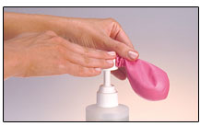

Mag-Movers Clik-Clik™ system is a lot more than magnets. It’s a full line of tools and accessories that can help you sell, showcase, and create unusual opportunities for you to be more creative and efficient.

No more rigging dilemmas on tall ceilings. A MagMover used with a Clik-Clik™ Magnet is a secure and inexpensive anchor for an amazing number of balloons. The larger size magnet can actually support up to 10 pounds! It’s easy to create ceiling treatments and other great tricks with Clik-Clik™ Magnets. For instance, they can act as anchors hidden under a tablecloth, wall treatments and much more.

Clik-Clik™ also includes Show-N-Sells, a merchandising system that can also act as framework for unique illusionary décor. The Adhesive Hang Tabs are one of the most creative ways to create mechanically sound arrangements. Strong yet almost invisible and a great tool for many
types of designs like the Magic Hot Air. A big 3 foot round hot air without a net—very impressive and more beautiful than your competitors tired old version..

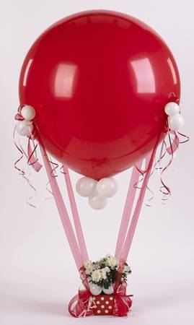
Magic Hot Air Arrangement

A standard hot air net is always a challenge to get on straight…and… what do you do with all those strings???

Helium fill a 3 foot latex and secure MagMover Adhesive Balloon Holders equal distant apart on the lower half of the balloon. Tie a ribbon onto the balloon neck with a heavy weight at the opposite end, then place the weight into the hot air container which has four more adhesive tabs in all four corners.

Tie on wide ribbon to the adhesive tabs on the balloon and then secure them to the tabs on the container. Snip the ribbon from the neck for a “magic” hot air arrangement. Look ma—no net!

For more design education, check out the following web sites…log on and inspire your very own creativity!

www.betallic.com
Check out bDecors for great design ideas with complete instructions, and bGallery to see the great work of many of our industry’s best balloon artists.
www.hi-float.com
Fabulous ideas, performance charts, and FAQs. Make your work more beautiful and long-lasting!
www.magmover.com
More beautiful options for rigging and designing—made easier than ever before by Clik-Clik™!

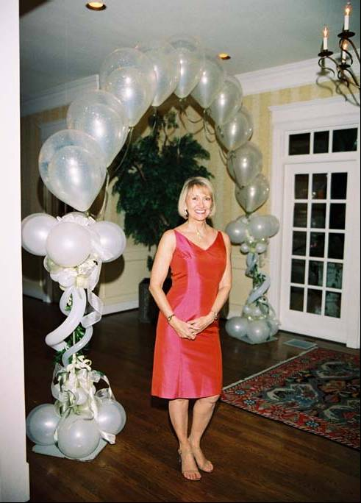

happy Designing!
Jan Iiams, CBA
Betallic LLC
Education Director
janiiams@betallic.com

Betallic welcomes new ideas from creative artists and would love to see your work appear in our new bFeatured section online and now in print. Send images of your designs, your name, contact and company information to us at decorator@betallic.com or twister@betallic.com.

