Helium Inflation Basics

With Betallatex latex, LINK-O-LOON®
and Betallic Foils
Balloons seem so basic it’s easy to overlook wasted
dollars from improper handling
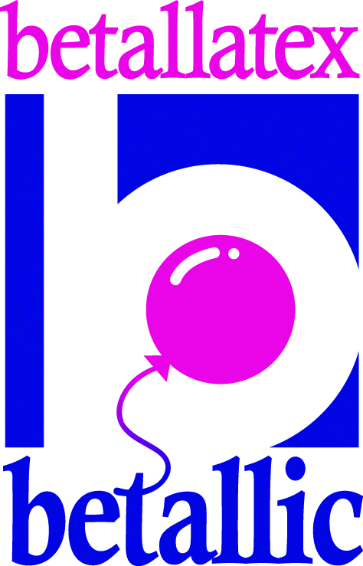
Don’t let the whimsical nature of balloons mislead you. You can spend a lot of money in wasted helium and balloon breakage—not to mention customer dissatisfaction—due to improper inflation.

First and foremost, use a high quality balloon to insure that your work is it’s most beautiful and performs beyond your customer’s expectations. Betallatex latex, LINK-O-LOON® and Betallic foils are not only unparalleled in color selection but perform exceptionally well under a variety of conditions in comparison to many competing products. Following are a few tips to insure you’re getting the most out of your balloons and that your work looks its most beautiful…

Efficiency and precision sizing saves time and money, and your perfect balloon designs will build customer loyalty better than any other effort to build a more successful business.

Valves: Different balloons, different needs

*Latex balloons
Some artist aren’t aware there are various types of valves available for use for filling latex balloons. Instead, they rely on their intuition for proper inflation. But you can waste a lot of expensive helium using this technique and float time results will be undependable. After all, unnecessarily over-inflating an 11-inch balloon to 13 inches uses twice the gas. Instead, opt for a digital inflator on which you pre-set the balloon size and the equipment automatically and consistently fills all of your balloons with the correct amount of helium.
*Foil balloons.
You cannot properly inflate a foil balloon using a valve designed for latex products. Judging the size according to whether the wrinkles on the crease disappear can cause you to easily over or under-inflate a foil balloon, especially when temperatures vary. An under-inflated balloon is eventually going to droop, and an over-inflated balloon wastes helium and is at greater risk of popping, especially in hot climates. For proper inflation, foil balloons require a valve that can sense the pressure inside the balloon and stop inflation when it reaches a certain level. Note: using this auto fill foil outlet also can increase the float time up to 30%! This is great for longer lasting, point of purchase sales. A foil tip : Make sure you tie ribbon to foil balloons below the valve opening. Tying above the valve can damage it and cause a slow leak. Also, if a balloon becomes limp, you can easily add more helium when you haven’t tied off the valve.

*Latex Longevity
LINK-O-LOON® and Betallatex latex perform beautifully in all weather and atmospheres but to really increase the float time of your latex balloons, always treat them with ULTRA HI-FLOAT® before filling them with helium.

*Always use the recommended amount of ULTRA HI-FLOAT® by using the restriction clips that come with your pump.

* There’s less chance of drips if you dispense into the bulb of the balloon rather than too close to the neck opening.

* Spread the treatment evenly around the interior and fill the balloon fully to insure the longest float time.
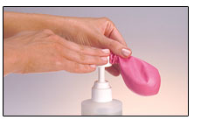

*Accessories
Ribbon is one of the best ways to make balloons look even more beautiful and one of the least expensive way to accomplish it. Following are a few rules that will set your work apart:
- In bouquets remember to make the ribbon tethers compliment the balloons, not stand alone visually. Pastels will look best with other pastels, bright with bright or even only 2-3 complimenting colors can make a lovely harmony statement.
- Use ribbon that is appropriate in size to the balloon. A three foot Betallic foil balloon just looks more balanced on a wider ribbon rather than regular curling ribbon. Add a small collar of 5 inch balloons or poufs of tissue or cello and literally for pennies, your balloons have a more professional appearance.
- Betallic containers and gifts that coordinate with latex and foils simply look like the arrangements are worth more—even though they relatively inexpensive accessories.
- Combining balloons in a variety of sizes in pleasing color combinations, and using non-round balloons can make a unique statement that will bring customers back for more of your creative work.

*Color
Betallatex has an unparalleled palette of balloon colors to offer your customers for every occasion possible. Add prints to the mix and you’ve created a beautiful way to add texture and interest which adds up to more profit for you. Following are a few important “rules” when combining and choosing colors for your customers:
- Complimenting colors are located directly across from each other on the color wheel. That’s why red and green look so beautiful at Christmas, and purple and yellow just “jump” at your visually.
- Triadic colors are three colors equal distance apart on the color wheel. Most traditional is red, blue and yellow.
- A monochromatic color scheme is made up of tints, tones and shades of one hue or color. For instance, red with white, gray and black added are pink, mauve and burgundy. A gorgeous choice for weddings!
- Analogous is three colors that lie side by side on the color chart like Red Violet, Violet and Blue Violet, or Lime Green, Green, and Blue Green. Lovely!

*Helium-tank do’s and don’ts
Helium (He) is the second-lightest element on earth. It is a colorless, odorless,
tasteless, non flammable gas.

Always:
① Strap the helium cylinder onto an appropriate and safe hand truck or dolly,
remove the filler valve and tightly secure cap when moving it.
② Store upright on a flat, level surface and secure in a safety stand, hand
truck or secure tanks to a wall with brackets.

*Education
Last but certainly not least is education. Following are some excellent resources for you to consider:
- Many distributors present educational classes to help their customers inspire more sales.
- There are a number of excellent national level seminars and conventions as well that are a terrific value when the return of the investment to attend is figured in. FLOAT, Twist and Shout, and distributor seminars are all quality education that shouldn’t be missed.
- Online education is a fantastic resource. Check www.Betallic.com on a regular basis to see new products and best of all, to get inspired with bGallery bDécor, Betallic’s step-by-step instructions complete with beautiful color pictures and an easy to use search tool to help you find ideas for décor for a variety of themes, holidays and occasions. You’ll even find delivery designs and centerpiece ideas and be able to recreate them from the complete instructions provided.
- bFeatured is a new educational section of our marketing materials showcasing the work of the best artists in our industry online and now in print.
- Betallic contests continue to raise the bar and inspire us all with entries from around the world. Check out bChallenged to see the winning results.

Good Designing!
Jan Iiams

Betallatex Education
and Creative Director

www.betallic.com



