
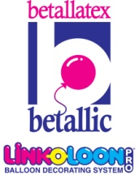
Here’s how to make
Valentine’s Day a FUNDAY

Valentine’s can be quite a challenge. Here are some tips to help you increase orders,
productivity, and profits on February 14.

b inspired
Make sure you have something beautiful and unique to offer. Experienced balloon artists who pursue Valentine’s Day business know it’s important to set their work apart to inspire sales. There are many ways to learn and develop fresh new balloon designs.
- Attend educational events. The cost is an investment, not an expenditure in your business. Many distributors offer excellent education year round and there are major balloon conventions held annually offering a wide variety of speakers and art.
- Online education is excellent and FREE at www.betallic.com as well as on a number of Betallic distributor websites. Betallic’s bGallery is easy to register for and has step-by-step instructions for Valentine’s Day and many other seasonal and themed occasions.
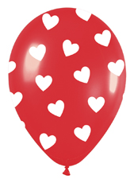

b smart
Buying is an important job so be prepared ahead of time for the big holiday.
- Begin to plan your designs early and shop before supplies of “hot” designs are depleted.
- Many distributors offer incentives for their established customers. Be sure to ask what specials they offer to see if it’s a creative fit for your bouquet designs.
- Choose wisely. Most people want a Valentine message but last minute customers will happily accept I Love You and other affectionate messages if they look Valentine appropriate. This allows you to sell leftover love designs for anniversaries later.

b organized

Create a timeline for every step and stick to it. Determine your
designs, prepare orders, plan your marketing strategies, organize staff
schedules and product, and be ready for additional orders that will roll
in once others see your beautiful work in person.

b friendly and fun
Your customers will love dealing with someone they who can guide them as they choose just the right arrangement to make a big beautiful impression. Make it personal. They will love the attention.
- Paint a verbal picture of the design itself as you talk to customers, but also describe the reaction their balloon gift will make to seal the deal.
- Ask choice questions about the recipient so you can quickly help them make the right choice .
- Have a list of a few enclosure card suggestions handy. Most people struggle with what they want to say and will love your cute ideas. Check out greeting cards for short sentiments and don’t forget to add your phone number to the enclosure card so more people can call you.



b visable
Creative marketing pays.
- For shops, air fill your foils and latex and display to show customers how beautiful your Valentine balloons are. Use Clik-Clik™ Show and Sell displays to show your wares and save space.
- For home based businesses, get friendly with other businesses that will display a bouquet a couple of weeks ahead and pass out your cards to their customers in exchange for their own free bouquet.
- Make calls in advance to businesses, gyms, salons, schools and churches you can offer multiple deliveries to for a discount or “free” small item with each bouquet.
- Offer a discount for arrangements on early deliveries. It could bring in more business prior to the holiday.
b prepared
Time is money, make it count. Pre-cut ribbon ahead and tie to foil balloon tails to ready them for speed inflation near the holiday, pre-fill foils a couple of days ahead since they have an extended float time, prepare bases for pre-sold designs and have small tie downs you can offer for last minute customers.

b profitable
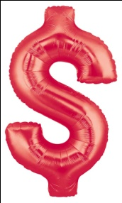
- Add bright latex to your repertoire of Valentine balloons. Many of your competitors only offer foils for Valentine’s Day since they can be inflated ahead and latex requires ULTRA HI-FLOAT® treatment which takes time. Betallic now offers FAST FLOAT™ latex balloons to make your work easy, fast and more beautiful. Betallatex FAST FLOAT™ latex balloons are pre-treated with the proper measure of ULTRA HI-FLOAT® already inside and are pre-strung with curled ribbon for fast assembly. BONUS: no mess, no guess. They come in reseal-able bags of 25 per color or print, and can be re-inflated the same as foils if you choose to prepare them a day or two ahead. Smart!
- Betallic HOLOGRAPHIC foils make an impressive visual statement, and are more competitively priced. Customers will choose them over regular foils every time.
- Betallic shapes are customer-catchers and last longer than typical 18” foils. Step up your creative designs and make more money.

Now, get ready to fall in love with the profit and success of your Valentine’s Day with Betallic.

Jan Iiams, CBA
Betallic LLC

www.betallic.com

.

