Dream Wedding Design
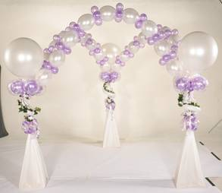
Jan Iiams, CBA
Betallic LLC

Welcome to the wonderful world of providing something simply beautiful for your bridal customer with the emphasis on “simple”.

The basics for creating sellable AND profitable décor is creative color use, harmony of elements, finely honed selling skills, do-ahead and efficiency focused systems and using beautiful accessory products to create wonderful wedding designs.
When you create an arrangement using the Principles and Elements of Design, both helium and air-filled design have a professional appearance when you apply these guidelines to shape, size, color, texture and theme. To produce the very longest lasting designs with air, there are a few tips I’d like to share that will keep your wedding centerpieces looking fresh even longer!
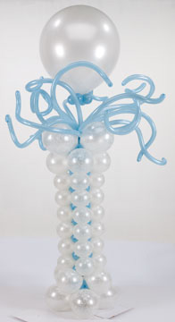
- Use opaque latex balloons whenever possible for arrangements that will be displayed for an extended time, or that will be exposed to outdoor light and air. When crystal balloons oxidize they appear cloudy looking. Opaque balloons (fashion, pastel, deluxe, pearl, and metallic latex balloons) do oxidize but are less obvious since they aren’t transparent. I prefer pearl and metallic balloons for weddings since they appear more formal.
- When using air-filled latex balloons in designs that are undersized, squeeze the air into the bulb of the balloon to create a shiny surface that is consistent with the other balloons in the arrangement, no matter what size they are
- Mechanics are important for arrangements that are very long lasting. If it’s on display at a bridal show for instance, there will be more inquisitive probing from admiring customers than for a design for a single evening event. Pan glue, hot glue, and cool glue guns, adhesives and various tapes to secure and cover are extremely important. Snipping off excess latex necks, curling, clipping or shredding ribbon tails will add polish to the finished product

Although helium has been the standard, the cost for air or nitrogen is relatively inexpensive and is appropriate for centerpiece bases and décor. Following are some tips and suggestions for non-helium balloon design:
- Use precision sizers or sizing templates like Clik-Clik™ Slide-N-Size to insure smooth, professional lines throughout designs.
- Without the magic of a lighter than air design, add simple special effects like battery lights, double bubble balloons and with Ultra HI-FLOAT®, you can create fabulous texture and color to your work.
- If prepping air-filled work a few days ahead, be sure to cover the inflated balloons with a plastic bag to protect them from oxidizing so they look freshly inflated.
- LINK-O-LOON® have moved to the top of balloons used in classic décor techniques when using air. When joined in groups or woven together, there are many opportunities to skip the base plates and poles since they can actually stand alone in many instances.
- Strong color harmonies are of tantamount importance in wedding work. Creating handsome design work is vital and so is sounding like a professional when discussing your work. Nothing impresses a bride more than a description that “paints the picture” for her and that sounds like an expert that she will have confidence in.
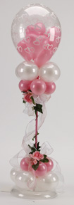
- Monochromatic – consists of one hue or pure color and it’s tints, tones and shades. For instance, red would convert to burgundy, mauve and pink which would be beautiful together.
- Analogous – is three hues that lie side by side on the color wheel. For instance my favorite is red-violet, violet, and blue violet. For weddings, the darker colors as an accent to white or ivory would create a rich, classic look .
- Complimentary – are two hues that lie directly across from each other on the color wheel like red and green, or purple and yellow. Softer complimentary colors from above could be pastel pink and pastel green, or lilac and ivory.
- Triadic – is three hues that lie equal distances apart on the color wheel like red, blue and yellow which in pastels would convert to pastel pink, pastel blue and pastel yellow.

Assembly of Centerpieces:
- Determine the final form of the centerpiece.
- Start with the highest vertical element to determine the height
- Insert the next element that determines the width
- Place the focal point
- Add the remaining primary elements to create rhythm
- Complete with fill materials to hide the mechanics
- Many times helium balloons are then added to this type of arrangement
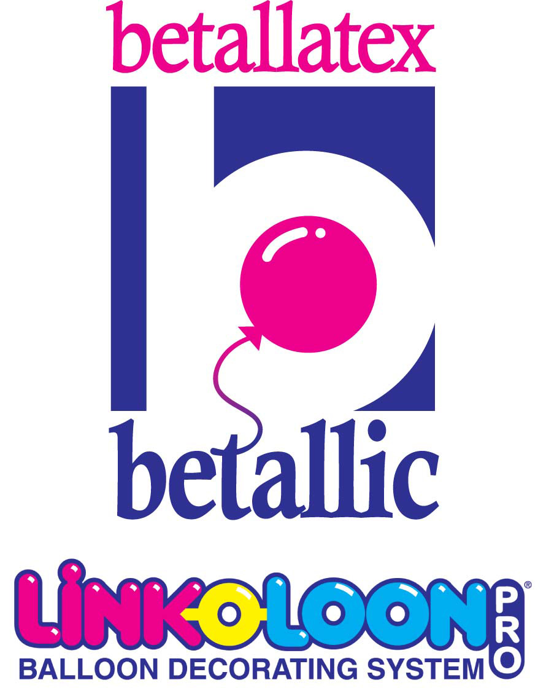

On a final note…by becoming familiar with the principles and elements of design and their applications in wedding centerpiece work, you’ll build a beautiful portfolio and a following of bridal customers who are looking for the best…You!

Jan Iiams, CBA janiiams@betallic.com
Betallic www.betallic.com

For step-by-step recipes for the above designs and to see many, many more for all occasions and themes, visit bGallery at Betallic.com.

