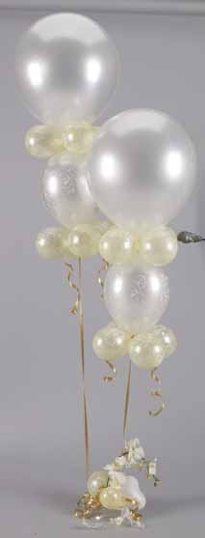
Dazzling Dance Floor Treatments

for Weddings

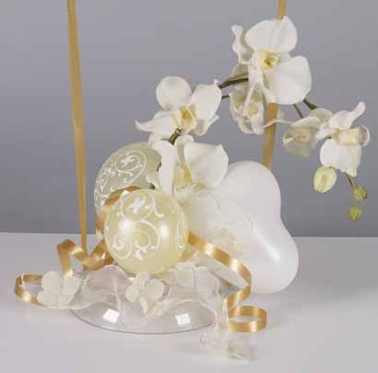
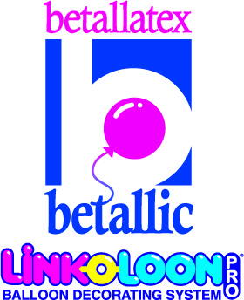
Jan Iiams, CBA
Education Director
Betallic LLC

I’ve always had a good intuition about what looks good, but after taking advantage of the educational opportunities our industry offers, my work has a much more polished appearance and I even sound more like a professional when discussing or describing balloon design. If your work looks professional, you’ll go far if you sound like the professional you are as well.

Using the proper terminology can instill confidence in your client. Just like using the word “monofilament” instead of “fishing line”…you just sound better! And, your customer may not know exactly why your work looks so wonderful, but they will recognize well-designed décor when you show it to them. Let’s learn how to make your work its best!

Now, let’s get started with a few basics…

When you create an arrangement using the Principles and Elements of Design, both helium and air-filled designs have a professional appearance when you apply these guidelines to shape, size, color, texture and theme. To produce the very longest lasting designs with air, there are a few tips I’d like to share that will keep your wedding centerpieces looking fresh even longer!
- Use opaque latex balloons whenever possible for arrangements that will be displayed for an extended time, or that will be exposed to outdoor light and air. When crystal balloons oxidize they appear cloudy. Opaque balloons (fashion, deluxe, pearl, and pastel latex balloons) do oxidize but are less obvious since they aren’t transparent. I prefer the soft finish of pearl balloons for weddings since they appear more formal.
- When using air-filled latex balloons in designs that are undersized, squeeze the air into the bulb of the balloon to create a shiny surface that is consistent with the other balloons in the arrangement, no matter what size they are
- Mechanics are important for arrangements that are very long lasting. If it’s on display at a bridal show for instance, there will be more inquisitive investigation from admiring customers than for a design for a single evening event. Pan glue, hot glue, and cool glue guns, adhesives and Clik-Clik™
- Adhesive Tabs to secure and cover are extremely important. Snipping off excess latex necks, curling, clipping or shredding ribbon tails will add polish to the finished product
- Although helium is the standard, the cost for air or nitrogen is relatively inexpensive and is appropriate for centerpiece bases and décor. It’s important to use a precision auto-size inflator or templates for perfect lines throughout your décor designs.
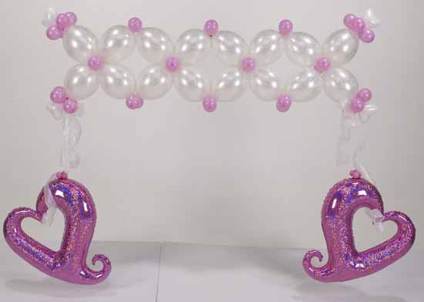

Strong color harmonies are of extreme importance in wedding work. Creating handsome design work is vital and, so is sounding like a professional when discussing your work. Nothing impresses a bride more than a description that “paints the picture” for her and that sounds like an expert that she will have confidence in.
- Monochromatic – consists of one hue or pure color and it’s tints, tones and shades. For instance, blue would convert to royal, azure and pale blue which would be beautiful together.
- Analogous – is three hues that lie side by side on the color wheel. For instance my favorite is red-violet, purple, and blue violet. For weddings, the darker colors as an accent to white or ivory would create a rich, classic look.
- Complimentary – is two hues that lie directly across from each other on the color wheel like red and green, or purple and yellow. Softer complimentary colors from above could be mauve and sea green, or lilac and ivory.
- Triadic – is three hues that lie equal distances apart on the color wheel like red, blue and yellow which in pastels would convert to pink, pastel blue and pale yellow.

Assembly of Centerpieces:
- Determine the final form of the centerpiece.
- Start with the highest vertical element to determine the height
- Insert the next element that determines the width
- Place the focal point
- Add the remaining primary elements to create rhythm
- Complete with fill materials to hide the mechanics
- Many times helium balloons are then added to this type of arrangement.

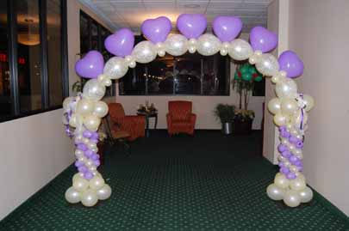

On weekends when you have many weddings scheduled, it can leave you and your staff overworked and the quality of what you produce can suffer. You may also be less likely to “sell up” and more likely to sell what is mundane and easy because you’re busy. Making and selling better or more advanced wedding balloon designs will make your profits grow, and your reputation for innovative designs will increase the number of wedding referrals you’ll get. Just a bit of planning ahead will allow you to fill space with wonderful designs and in record time.

LINK-O-LOON® are a beautiful and creative way to offer unique designs that is set apart from typical décor that has become dated and expected. Best of all, LINK-O-LOON® are labor friendly and offer many air filled and frameless options that are more profitable as well as more visually exciting. Visit Betallic’s online bGalllery to view “how tos” for designs complete with instructions, product lists and to source products by occasion and season.

Foils are a very impressive way to add visual value to décor which typically is designed with latex. Holographic foils add elegance and interest to columns, arches, canopies and even in centerpieces.

Offering special effects can not only make you more money in sales and rentals, but can enhance your reputation for being a trend-setter for the bride who doesn’t want a cookie cutter wedding. Offering something special can catch the eye of brides at bridal shows and while perusing your portfolio. Special effects can include romantic lighting, special textures with paint and fabric, turntables, confetti showers and exploders that release small balloons at specific times.

With just a little imagination you will find your bridal customers won’t be able to resist the dash of romance you add to simple classic décor designs.

On a final note…wedding designs should be beautiful and profitable. By becoming familiar with the principles and elements of design and their applications in wedding centerpiece work, you’ll build a beautiful portfolio and a following of bridal customers who are looking for the best…You!

Jan Iiams, CBA
janiiams@betallic.com
www.betallic.com for beautiful step-by-step balloon recipes for weddings, holidays and more!

