The following articles written by Sean O’Kelly of BALLOON DÉCOR in Australia are the first in a series of brief descriptions demonstrating how any small business with even the most limited computer knowledge and experience can make the most of a professional standard Computer Graphics Software Package and enhance their professional image overnight with the click of just a few buttons and the wave of the mouse.

A lesson in becoming more familiar with the Computer Graphics program CorelDRAW X4®
Specially prepared for Betallic® and Betallatex™ Balloons
By: Sean J. O'Kelly, Balloon Décor
Dingley Village, Melbourne, Victoria, Australia
www.balloondecor.com.au

If you want to make the most of a computer Graphics program you must familiarise yourself with the many functions available within the program. I have prepared below a brief outline of some of the many magical ‘Tools’ in CorelDRAW X4® I use to create the hundreds of ‘Balloon Industry’ specific pieces of clip art which I in turn utilise to make produce Brochures, Flyers and Catalogues, Information Sheets and Quotes which are printed or sent via the internet. ‘The program is not hard to learn ………..what is hard is deciding which ‘Tool’ to use first.’

I hope this brief description of the CorelDRAW X4® interface is of use to you when you download your FREE trial version from the Corel Website www.corel.com. For additional information you can email the author direct sean@balloondecor.com.au or first contact www.betallic.com
Other articles in this series will soon be available

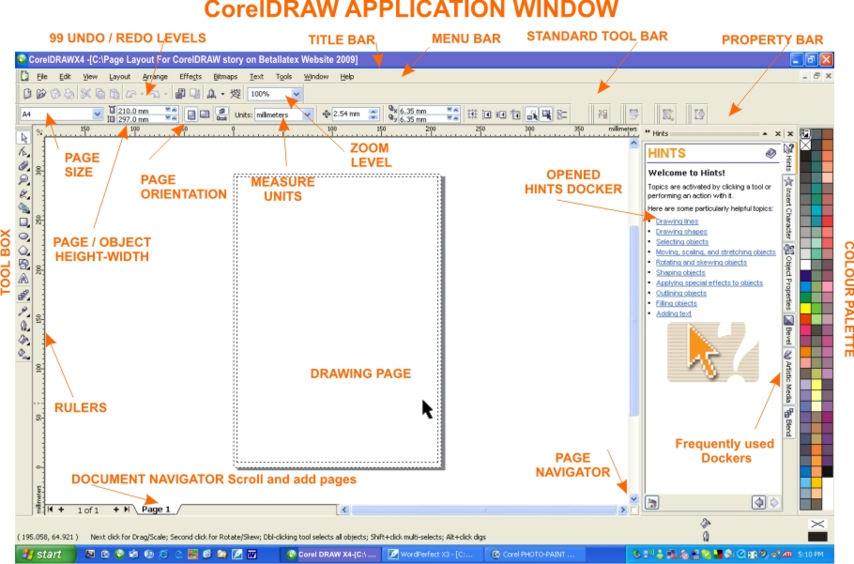

Application Window:
Work Area:
You open your pages and documents in this window, adjust settings and activate Tools as you would with any conventional Word Processor or Desktop Publisher.
You will find the Title, Menu, Standard and Tool Bars at the top of the screen.
At the bottom left of the window is the Document Navigator tab allowing you to add/select pages.
On the bottom right side is the Page Navigator allowing you to scroll to new areas of the page while in ‘close-up zoom mode’.
You create your graphics, import/export clipart and photos to and from a Document Page.

Dockers:
Dockers are display windows on the right hand side of the screen and contain various levels of information related to the using and selection of particular Tools. Frequently used Dockers can be displayed as quick activation Tabs in the Docker area.

Eg: Window (on the Menu Bar) > Dockers > Hints.
Hints Docker:
The first feature you should become acquainted with is the Hints Docker. A very helpful ‘selection activated’ guide for using the program. As you select each Tool the ‘how to use’ information is displayed in the Docker window on the right side of the screen.

Options Window: Hotkey Ctrl-J
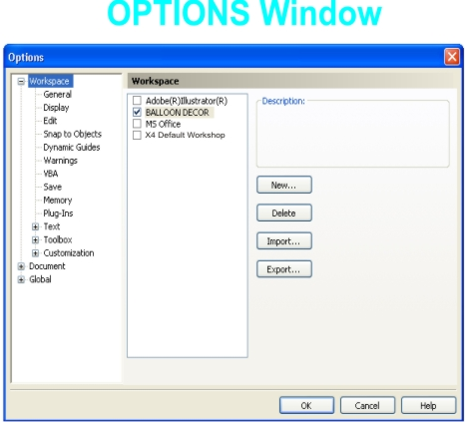
Another important feature is the Options window

Tools (on the Menu Bar) > Options
Within the Options window you will find a large selection of Default Settings which can be adjusted to suit your personal usage.
[I recommend that before you begin adjusting any of the Factory Default Settings that you create you own Workspace. ]

Tools (on the Menu Bar) > Options > Workspace.
Once in the Workspace section you can choose from the provided clones or select the ‘new button’ to enable you to create your own personal Workspace (as you can see in the Diagram, I have done this for BALLOON DECOR) thus leaving the X4 Default Workspace in it’s original setup.
Within Options you can set new Defaults. Eg: adjust the Document size and settings.

- Help: F1
Help (on the Menu Bar) > [make your selection]
If you don’t have the patience to continually learn by your mistakes but to have the good sense to read the printed Help information provided then you will find working productively between the two programs will be a smooth logical process.
Additional Help is available through the program loaded many useful tutorials and links to the Corel Help on the Web Site http://www.corel.com/
If you wanting to join a chat-group I suggest you try the Yahoo Group CDU (Corel DOWNunder) or visit their web site www.coreldownunder.org.au . I have been a member of the group for many years and owe a large percent of my understanding of what the program can do to the advice provided by the group.

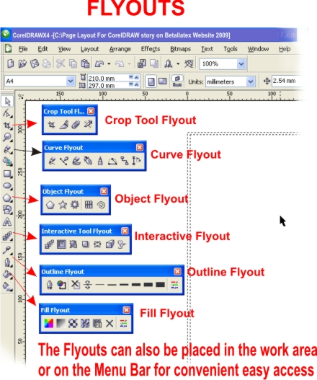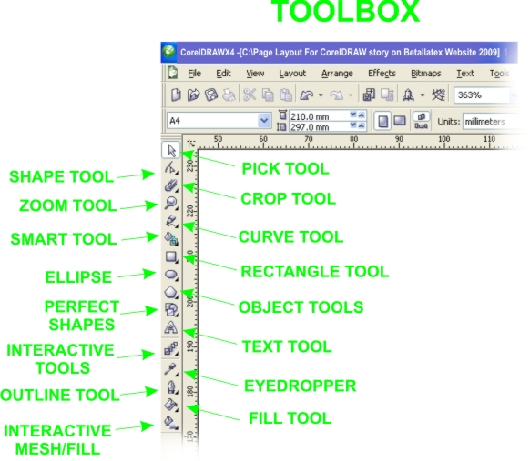

- The Toolbox:
Situated on the left side of the screen the Toolbox allows of quick access to a variety of Tools.
The Toolbox is as the name implies the area where you open the most common Tools such as-Text - Fill and Zoom. By selecting the Tools with the small triangle in the bottom right corner of the Tool allows it to ‘Flyout’ as shown by the examples shown in the Diagram. Tools can be positioned anywhere on the screen. The Tools that allow fly-outs display either similar Tools or variations of the one Tool.

- Flyouts:
Found along the Toolbox Flyouts are additional Tools and settings.
Flyouts are noted by the small triangle in the bottom right corner of button indicating that the set of Tools and settings can be positioned anywhere within the Application Window ready for easy access.

- Text:
The Text Tool is activated from the Toolbar by selecting the ‘A’.
Fonts/size/colour can be chosen from the drop-down windows on the Property Bar.

- Types of Text:
Paragraph Text is activated by selecting the Text Tool and then by placing the curser anywhere on the page and while holding the left mouse button, drag the mouse down to the right to make a box. This box becomes the parameters for your paragraph text sometimes know as a ‘text box’
Artistic Text is also activated by selecting the Text Tool and then by clicking anywhere on the page. A blinking marker appears allowing you to begin typing. Once you have typed the first letter a set of ‘nodes’ appear allowing you to expand and reduce the size of the text to visually fit any area.



Breaking Text Apart
Once you have typed/selected BETALLATEX you can select.
Arrange (on the Menu Bar) > Break Artistic Text.
This will allow you move/flip/rotate each letter individually as shown in the above graphic


- Fit To Path
Artistic Text also allows you to place the text along any path as shown in the above graphic.
By typing a sentence in Artistic Text and then using the Ellipse Tool create a circle. (by holding the Ctrl Button down while making circles or squares will ensure they have even dimensions)

Text (on the Menu Bar) > Fit Text To Path.A black arrow appears allowing you to position the text along any line As you can see in the two examples below the text can now be placed anywhere along any line

Written by Sean J O’Kelly
BALLOON DÉCOR, Australia
For Betallic Ballons
sean@balloondecor.com.au
www.balloondecor.com.au
Copyright:
All graphics, page layouts and designs and information presented wherein this article entitled ‘Corel X4 Getting To Know You®’ is acknowledged as being held in Copyright© 2009 by Balloon Décor Australia with publishing rights granted to Betallatex®. All rights reserved by both parties.
No portion of these notes may be republished through any means without prior written permission of the Copyright holder.
All inquiries to be directed to the author c/o sean@balloondecor.com.au.

All trademarks and product names are acknowledged as the legal property of their respective individual Copyright owners.
Specific ownership is credited to Corel Corporation® Betallic, LLC ® Betallatex ®

Disclaimer:
The information contained herein wherein this article entitled ‘Corel X4 Getting To Know You®’ have been provided as a guide only. Explanations, methods and terminology used within may differ from simular documentation provided with the actual software program or simular software program. Should any conflict occur you are advised to refer to the Users Guide provided with the particular software program.
No information provided in these notes has been exclusively endorsed by any software company.
The author and or publisher shall bear no responsibility or liability to any persons or entity in respect to any loss or damage arising as a result from following the information contained in these described notes.

