Cooking Up Summertime Décor!
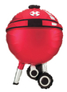
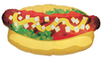
Jan Iiams, CBA
Betallic Education Director

Everyone loves summer; it’s the perfect time to decorate and celebrate! Here are a few marketing tips to get your mid year cash register ringing:
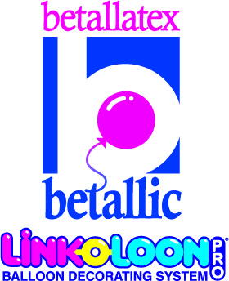

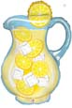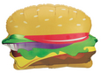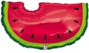

Betallic foil shapes

Dialing for Dollars
Getting corporate business is as easy as opening the phone book and dialing for dollars! A personal call is warmer and can be harder to say “no” to. Especially customers you’ve served in the past. A well-organized phone campaign works best:
- Get in touch with everyone whom you have built a business relationship.
- Call last year’s clients. Start with the high-ticket prospects and work down.
- Schools celebrate graduation, end of the school year and fund raisers. What a perfect time and place for balloons. Get in touch with school committees and make friends with the staff at your kids schools to become THE balloon décor company.

Malls: Potential Profit Triple Play!
- Contact malls and offer décor special events and major mall sales events.
- Approach individual stores for window display opportunities. Air-filled options are less expensive to create and last and last. What a perfect time to offer LINK-O-LOON® décor!

Score a Home Run with Hotels!
- Get to first base by contacting the catering manager for an appointment to show how you can help solve their clients decorating dilemmas.
- Then contact the people in charge of lobby décor for a double.
- What about offering a finders fee for wedding reception business they send your way for a triple play?
- Score a décor sale this summer for making friends at the hotel now for the big New Year’s Eve bash! The hotel is charging admission, advertising heavily, and the decorations are already built into the budget! It’s a home run!
Make Contact!
With caterers, party planners, DJs, restaurants, country clubs, recreation halls, and community centers.

Dazzle Them with Your Expertise!
Summer is a great time to sell outdoor décor for charity runs. Make sure you step up the size of helium balloons, offer foils that float longer or best yet—air filled décor which looks great longer with no worries about helium that doesn’t float very long outdoors.


The Theme’s the Thing!
Your customer will be looking to you for guidance when
it comes to current trends, seasonal and popular summer themes.
Use latex for seasonal color and add Holographic foils to add interest,
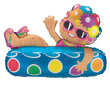
message and visual value.

Wave the Flag!
Check out patriotic recipes for impressive flag themed décor.
Go to www.betallic.com, register for bgallery (it’s free) and click on

Patriotic under the Occasion drop down in the bDecor search.

Express Décor
Of course, not every customer needs full-fledged, on-site

décor, so make sure to offer Express Décor Packages, i.e.:
- Ceiling of balloons
- Bulk deliveries
- 3’ latex on cello
- Holographic foil shapes and coordinating 18” bouquets

Balloons Deliver! Betallic foil shapes
While the focus of the season may be centerpieces and décor, don’t overlook delivery sales. Target companies and individuals who are likely to need multiple deliveries, i.e.:
- Corporations – Bonus checks, employee gifts and gifts to colleagues and clients are more exciting to receive when attached to balloons!
- Professionals – Doctors, dentists, lawyers, real estate brokers and travel agents often have very large gift lists. Help them see balloons as a solution!

If you make yourself indispensable to these customers this summer, you’ll probably find yourself serving them all year’ round!

