

A lesson in Creating a Balloon Garlands with your Computer
Specially prepared for Betallic and Betallatex™ Balloons
By: Sean J. O'Kelly, Balloon Decor
Dingley Village, Melbourne, Victoria, Australia
www.balloondecor.com.au

We all know that with our Betallatex™ Balloons we can create thousands of different sculptures and displays. In this article I will demonstrate how you can conveniently use a computer ‘Graphics Program’ to design and present this décor before you have inflated a single balloon. Columns, Arches, Bunches and original designs can all made with a few clicks of your mouse. In minutes you will be able to inflate and size dozens of the balloons colour them to suit your favourite Betallatex™ Balloons insert them in to a photo, and forward it on to a client giving them a visual interpretation of their finished décor all.

For more than 10 years I have made all my own ‘décor specific’ clip art for use in quotes, presentations, instruction sheets, flyers and in Web pages. I feel confident that once you have realised the convenience of Graphic Drawing Package you will be eager to make your own theme specific brochures, flyers, or even a catalogue for publication or simply convert them into the widely used PDF format internet distribution ….. You can even design a logo and layout your own business cards, print labels or layout artwork for balloon printing.

My personal choice in Graphics Programs is CorelDRAW X4® which also comes with the additional integrated program PhotoPAINT® which is used for cleaning and enhancing photographs. The instructions below cover a simple explanation of DRAW’s interface and the position of my most commonly used ‘Tools’. It also describes the basic steps in creating a 4Balloon Cluster Spiral Garland and the method to converting them into simple to use ClipArt. Once you have mastered these simplistic procedures, you will know the basics for creating any number of simular pieces of decor. These ‘steps’ are only a small example of the power of a modern graphics program and you will require a Graphics Suite with the computing power of CorelDRAW X4®. If you like what you see and I know you will, you can try before you buy. Visit www.corel.com you can download a FREE ‘trial version’ of CorelDRAW X4® allowing you to recreate everything I show here and advance that step forward and to designing even more creations with your Betallatex Balloons®.

I hope this brief description of the how to create a Balloon Garland with CorelDRAW X4® is of use to you. For additional information you can email the author direct sean@balloondecor.com.au or first contact www.betallic.com
Other articles in this series will soon be available.

Getting to Know the Workpage:

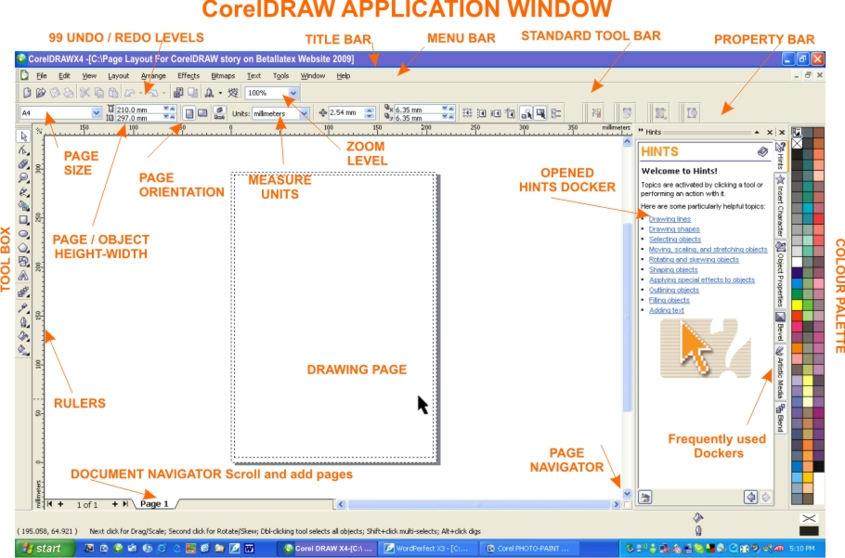
Many of the ‘tools’ available within the program are self explanatory and I also suggest you be brave and adventure forward by investigate their purpose.
If you Select ‘Window’ on the Menu Bar > Dockers>Hints you will activate the ‘Hints Docker’ which is a ‘Help menu’ that gives you a brief description of every tool you select.

CREATING A GARLAND
When sizing is still important

It is vital to remember that when graphically presenting a 3Dimensional sculpture such as a Balloon Garland in a 2Dimensional medium that although there may be many more balloons in the sculpture in the presentation only a limited number of the balloons can be seen at one time.

To Begin:
Go to File on the Menu Bar at the top of the Application Page >New and a new page will appear in the Application Page

Step One:
Select the Ellipse Tool (for making circles) located in the Toolbox displayed on the left hand side of the Application Page.
Draw a circle on the page by dragging the mouse while holding down the left button.
If you have trouble creating a ‘defined measurement’ circle you can set the measurements on the Property Bar at the top of the screen as displayed in [Figure One.] or hold down the Ctrl (Control) button on the keyboard while dragging the mouse.
While the 1st circle is still selected ‘left click’ on WHITE in the Colour Palette on the far right hand side of the Application Page, this will fill the circle with a white colour allowing you to overlap each new circle.

Step Two:
After selecting the 1st circle press the Copy & Paste (Ctrl C+V) buttons located on the top Property Bar
The 2nd circle will now be located directly over the first. By pressing the right arrow button on the keyboard or by using mouse move the 2nd circle to directly beside the 1st. [Figure Two]

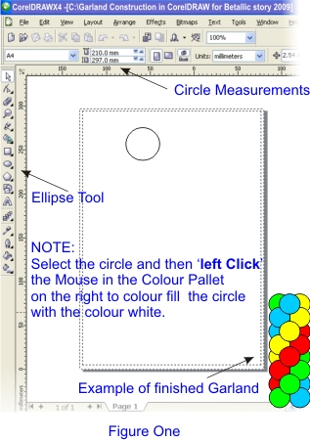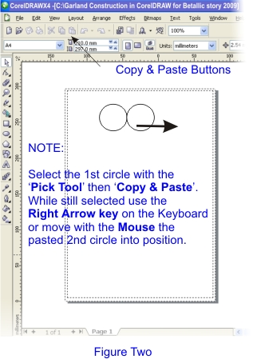

Step Three:
Because you have already copied the 1st circle to the clipboard you can now once again press the
Paste Button and another (3rd) circle will appear directly over the 1st.
Move the 3rd circle into position between the first two by once again using the mouse or the right arrow key. [Figure three]

Step Four:
Now that you have created the three (revealed) balloons of the first cluster you can move on to creating the second cluster.
Select the 1st and 2nd circles created and Copy & Paste (Ctrl C+V) as you have done in the last two steps.
Once again using the arrow key or the mouse, move the two pasted circles DOWN to create the second Cluster as shown [Figure Four]
Ensure that the middle circle of the first cluster is placed on top by Selecting it and then pressing Shift and the Page Up button on the keyboard to bring it to the top layer.

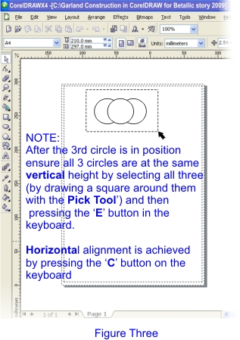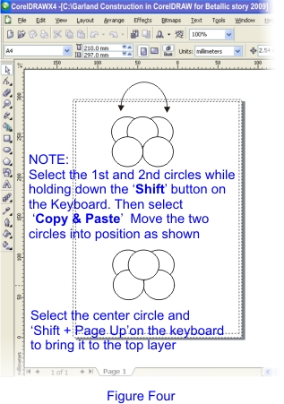

Step Five:
You should be excited by now for you have just created two clusters and you still haven’t inflated a balloon.
With the Pick Tool as described in Figure Three draw a box around the all five circles (two clusters) at once.
Press the ‘Copy & Paste’ buttons once again and move the two new clusters DOWN into position as in one of the previous manner described. [Figure Five] Hold the ‘Shift’ button down and Select the 6th and 8th circles and then while still holding the ‘Shift’ button down press the ‘PgDn’ (Page Down) button on the keyboard.

Step Six:
Once again with the ‘Pick Tool’ as described in ‘Figure Three’, select the now ten circles and ‘Copy & Paste’. Move the ten new circles into position. Ensure the 11th and 13th circles are sent to the rear by following the same as described in Step Five. [Figure Six]

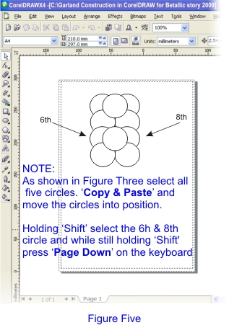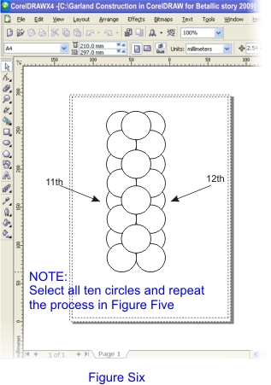

Step Seven:
Holding the ‘Shift’ button down select the appropriate balloons to be coloured in a spiral (or any other pattern) then by ‘Left Clicking’ the Red colour in the colour palette begin to create the pattern. [Figure Seven]

Step Eight:
Repeat the process in Step Seven to colour the remaining balloons in the desired pattern.
Now SAVE your garland for future use.

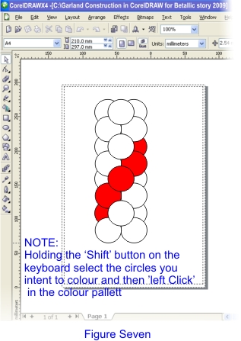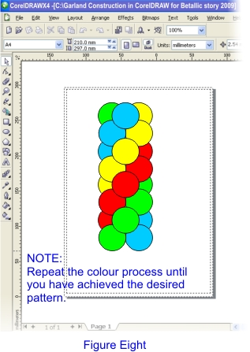

Making use of your new Clip Art.

Many Word Processors or Desktop Publishing Programs only allow you to work with your created Clip Art within their own environment, thus restricting you from utilising the art work in other programs or conveniently forwarding them on via email for a client to view. CorelDRAW X4® allows you to import/export many different file types such as bmp, jpg, gif, tif and eps along with many more. This feature is extremely useful when you need to send the ‘Clip Art’ to a client via email in the body of an email or as such files as a MS Word Document.

In the case of your newly created Garland and any other designs you may create, you could:

1: Select it and export File> Export File (Ctrl-E) it as a Jpeg file (or a variety of other files) to be stored on your hard drive, sent anytime to a client via email, place in a page within another program, printed out or even displayed on your Website.

2: Save it as a CorelDRAW X4® file and Import it anytime back into a new Corel page to overlay it into a picture of an empty venue to show a client how their finished décor would look.
Of course your colours ( of the Garland or sculpture) can easily be changed to suit a clients needs and theme.

Once you have mastered the ‘steps’ to create one Garland there will be no stopping you, soon you will be designing all sorts of Sculptures on your computer.

Written by Sean J O’Kelly
BALLOON DÉCOR, Australia
For Betallic Balloons
sean@balloondecor.com.au
www.balloondecor.com.au

Copyright:
All graphics, page layouts and designs and information presented wherein this article entitled ‘Computing A Round Balloons’ is acknowledged as being held in Copyright© 2009 by Balloon Décor Australia with publishing rights granted to Betallatex®. All rights reserved by both parties.
No portion of these notes may be republished through any means without prior written permission of the Copyright holder.
All inquiries to be directed to the author c/o sean@balloondecor.com.au.

All trademarks and product names are acknowledged as the legal property of their respective individual Copyright owners.
Specific ownership is credited to Corel Corporation® Betallic, LLC ® Betallatex ®

Disclaimer:
The information contained herein wherein this article entitled ‘Computing A Round Balloons’ have been provided as a guide only. Explanations, methods and terminology used within may differ from simular documentation provided with the actual software program or simular software program. Should any conflict occur you are advised to refer to the Users Guide provided with the particular software program.
No information provided in these notes has been exclusively endorsed by any software company.
The author and or publisher shall bear no responsibility or liability to any persons or entity in respect to any loss or damage arising as a result from following the information contained in these described notes.

