How to Sell Bigger Projects and Guide Your Clients From A to Z
- Balloon decorating from your clients perspective -

Guido Verhoef, CBA
Manifold – Netherlands
www.theARTofBalloons.com

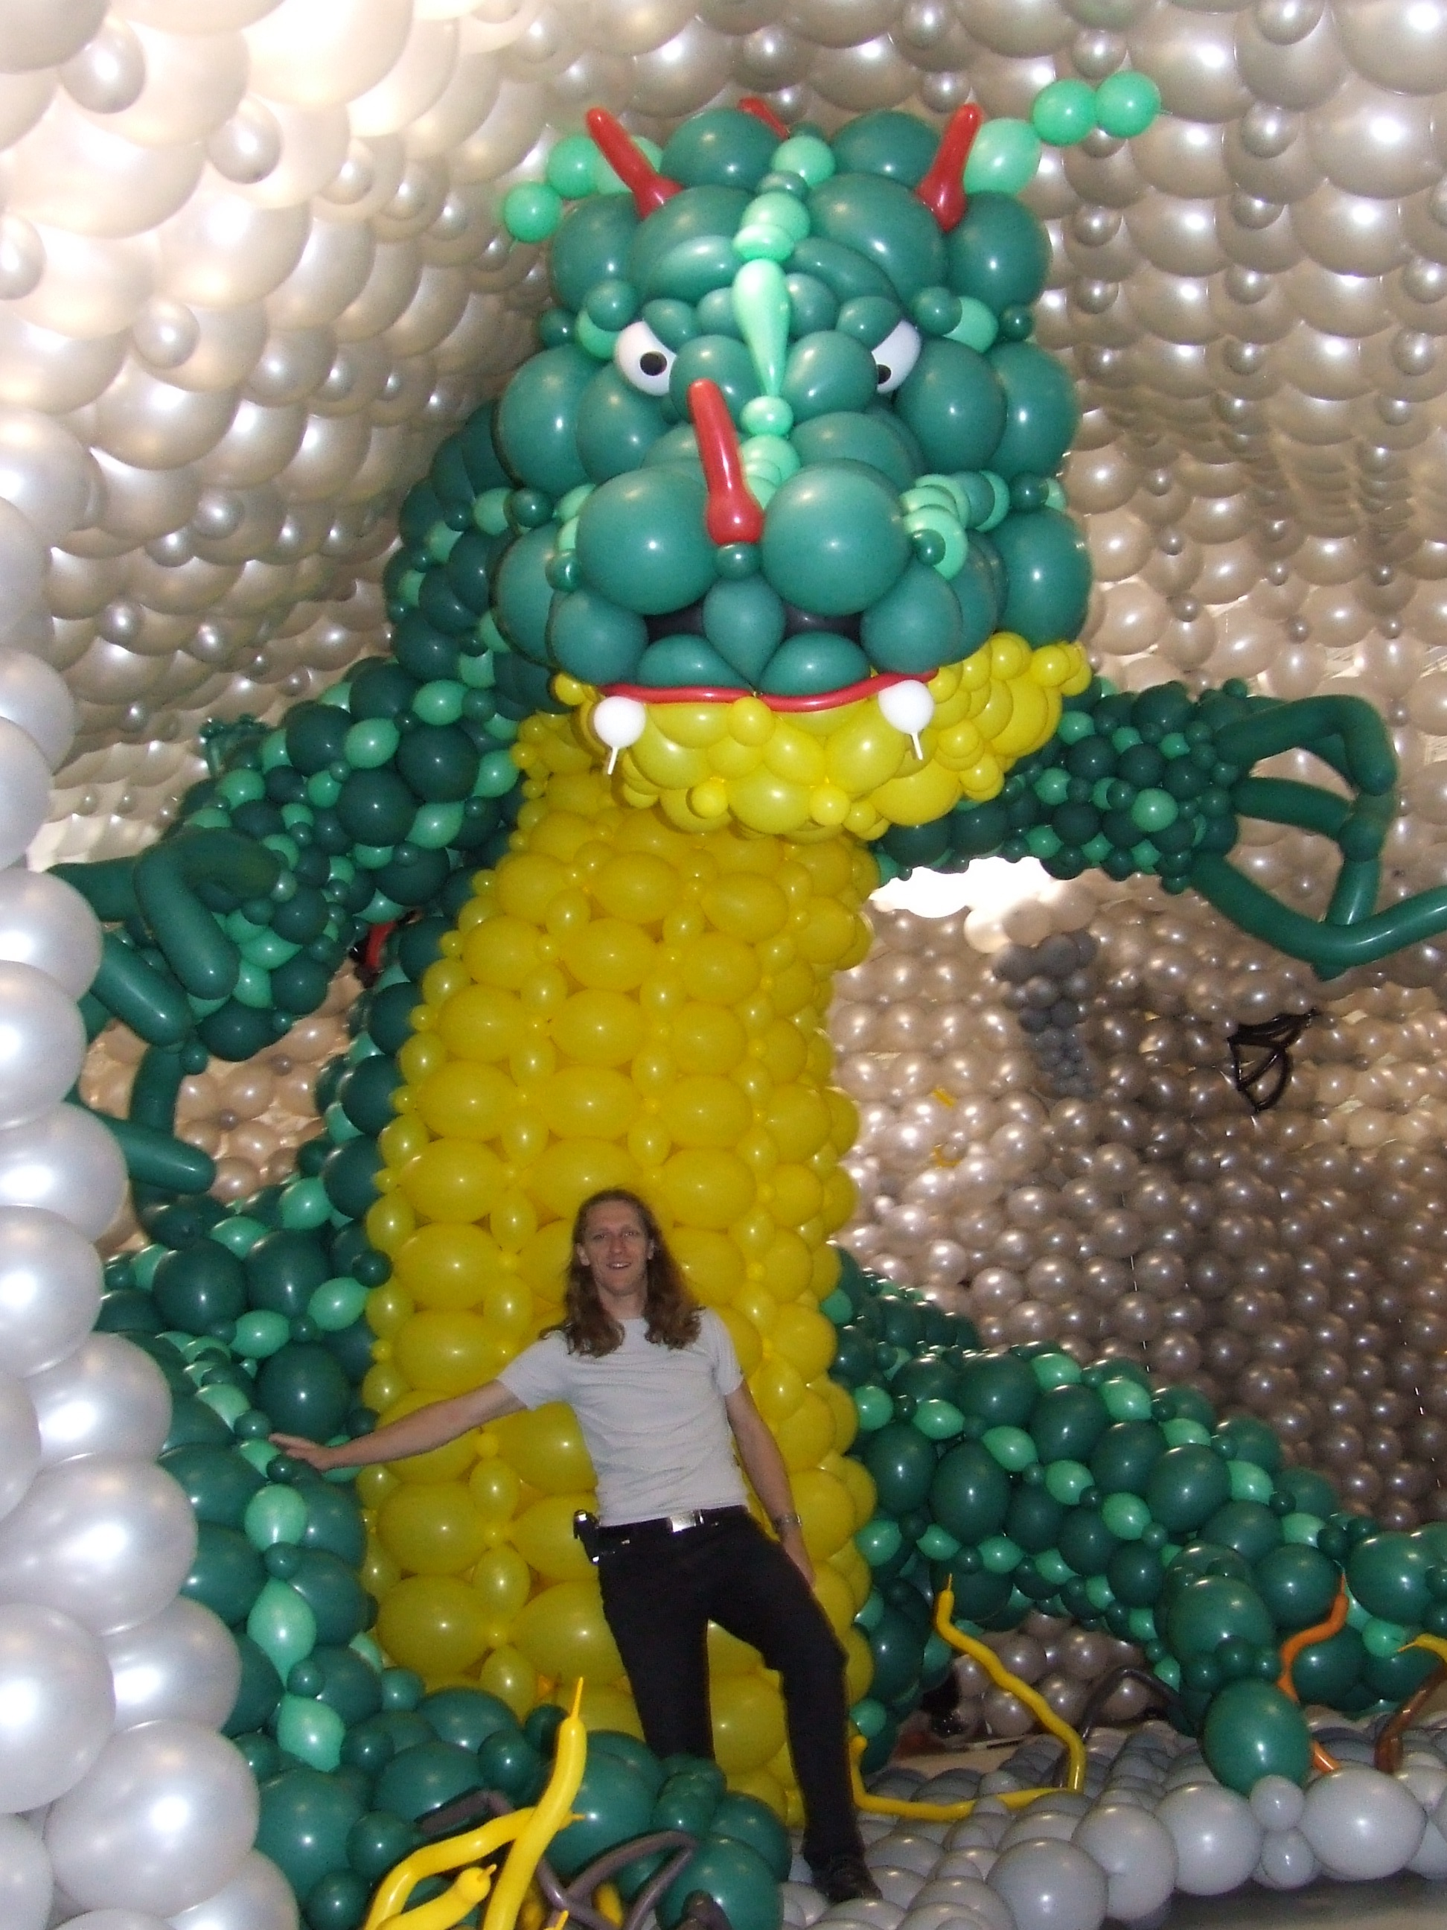
One of the first questions decorators often ask themselves if they see pictures of a large balloon décor or project is, “How did a decorator sell this?” or “Which client asked for a project of this size?”

A lot of decorators show their portfolio on a brochure or a website and wait by the phone for customers to call them up and hope to get lucky from time to time and get asked for those big jobs.

In reality it happens sometimes, that large companies, malls or event organizations know exactly what they want and also have the budget for it and don’t know where to go.
So is it just luck of the draw that they call you or can you “work the market” and create a demand in your own circle of potential customers?
Do costumers always know exactly what they want and how endless the possibilities are with balloon decorations? And what about their budget?

Even for a lot of decorators it’s difficult to think in endless possibilities and to see the challenge beyond their comfort zone of building day to day basic décor.
Here are 6 guidelines that may help you to expand your business and enjoy more the creative side of balloon decorating.

1. A Professional Attitude
Companies will only trust you with larger projects if your company makes a trustworthy impression on them. To gain this trust you need a professional attitude.
This doesn’t mean that you have to drive a big car or wear expensive suits if you meet clients although I wouldn’t deny that in some business circles you get more done. Your costumer service, the way you approach your clients and the way you organize your office are all aspects that have influence on the image of your company. But the most important is an open and clear relationship.
If you are not sure about a décor job or you have another opinion about the décor your client asks for, discuss it openly. Advice them and give some alternatives and try to get your client involved in the process.
If you make a mistake or something goes wrong with the decor take responsibility for it and discuss the options to solve it or prevent it the next time.
Sometimes this means that you loose smaller short term costumers but on the long term you will find out that this is the best way to build on durable relationships with bigger costumers.
When there is a foundation of trust they will give you a lot of space to come up with your ideas and create the décor you advice as the professional.

2. Your Reputation
To build up a reputation takes time and a constant quality in your work.
Even if you are not one of the “well know balloon companies” who always do the large decorations and had time to build up there name it’s possible to work on your portfolio by building larger decorations and sculptures on charity events or at balloon conventions. This often gets the costs of your balloons covered and gives you the opportunity to practice and become more experienced.

3. A Well Structured Company
To be able to create large sculptures you need a well structured company that uses good equipment, the right employees or colleagues and trustworthy colleague-companies.
Good equipment from Conwin, Hi-Float, Premium Balloon Accessories and MagMover and high quality balloons as the rounds, non rounds, Link-O-Loons and foils from Betallic, a good storage system, etc. gives you the opportunity to work clean and fast and saves you valuable time.
Hard working, flexible and positive employees or colleagues are also necessary. Negative or slow working people often slow down the whole process.
When you want to work on large scale projects it’s necessary to build on good relationships with trustworthy colleague-companies. Often you will need help with employees, expertise or equipment and if you team up with the right company, you double your strengths.

4. Thinking From the Clients Perspective.
Often a client calls you up and asks for a specific décor but has a two dimensional idea about it. If your first questions are “What kind of company do you have?” “Where is it for?” and “What do you want to achieve on this event?” you show your client that you are not only interested in selling your product as quick as possible but that you are willing to think from their perspective to create the best effect possible. Getting answers on these first questions helps you to create a rough idea on what they want to achieve and which décor suits them the best instead of thinking after the installation of the décor “I should have done this, that would have fitted perfect in their company.”
When you ask about what they want to achieve by using balloon décor you get to the core of the question why they are willing to spend money for balloon décor. Customers don’t see all the benefits and possibilities to the full extent, and you will find out some customers didn’t think about this question at all and just order balloon décor because they always do.
If you help them answering the question “why” you increase the importance of the décor and are able to build on their initial ideas and add more easily new ideas because you already made their horizon wider.

5. Expand their Budget
Answering the question what they want to achieve with their event or balloon décor increases the importance of the décor. Do they just want to show the people that there is an event or do they want to attract an audience with an eye catcher or do they want to impress their clients by giving them a visual reminder that is connected to their company. And how long do they wish that the audience will remember their company décor. One week, six months, two years, ten years?
If you ask a company a question like this, you help them to see the promotional value and the possibilities that can be achieved by using balloon décor.
Of course to achieve the effect that people still remember the décor you build after one year, making a balloon arch is not enough. You have to make an estimation of how big or innovating your decoration has to be to maintain this effect.
On every scale there is a different price, but the budget for promotion is much bigger than the event (just for fun) budget.
The same principle goes for company events if you ask what the company wants to communicate to their employees on the event. Is it just to decorate the room or do they want to communicate that the company is really proud of them and that they are really valuable for the company. By communicating this you build up the moral and you get a stronger commitment from your employees. If you want to communicate as a company that your employees are valuable do you achieve this by spending 100 dollar for the décor.
But maybe the company wants to work on teambuilding, education or the company growth.
These are all areas where you can use your balloon décor as a support to underline the company message they want to communicate. And immediately you will see that the educational budget is much bigger than the company event budget.

6. Innovation and creative ideas
To be able to pursue your potential customer in buying a large sculpture or décor you have to present creative ideas that are beyond their expectation. This doesn’t mean that every idea has to be innovating for the balloon industry, as long as it is new for your customer and the audience you are innovating in their eyes. Be inspired to create and adjust your own sculptures by visiting various balloon conventions, and looking at pictures as shown on Betallic’s bGallery site. You don’t always have to invent the wheel again, just painting it in a different colour often does the trick.

