Air-filled Décor Makes Money Sense
With Added Profit and Longevity
by Jan Iiams, CBA Betallic LLC

With cost and helium availability issues today…
add new artful air-filled Betallatex décor options
to increase your creativity AND your profits.

How would you like to learn a few simple techniques for creating decor your customers will love, that has a high perceived visual value, made from low cost elements, and that allows you to expand your creativity…without using a lot of expensive helium? You’ll be “walking on air” when adding more air filled balloons to your design repertoire.

Helium is expensive and availability can be uncertain. The answer? Less helium and more air. In this class you’ll see examples of backdrops, columns, centerpieces, ceiling treatments, arches and more, all with less helium…more air!


REASONS YOU’LL LOVE MORE AIR FILLED DESIGN OPTIONS:

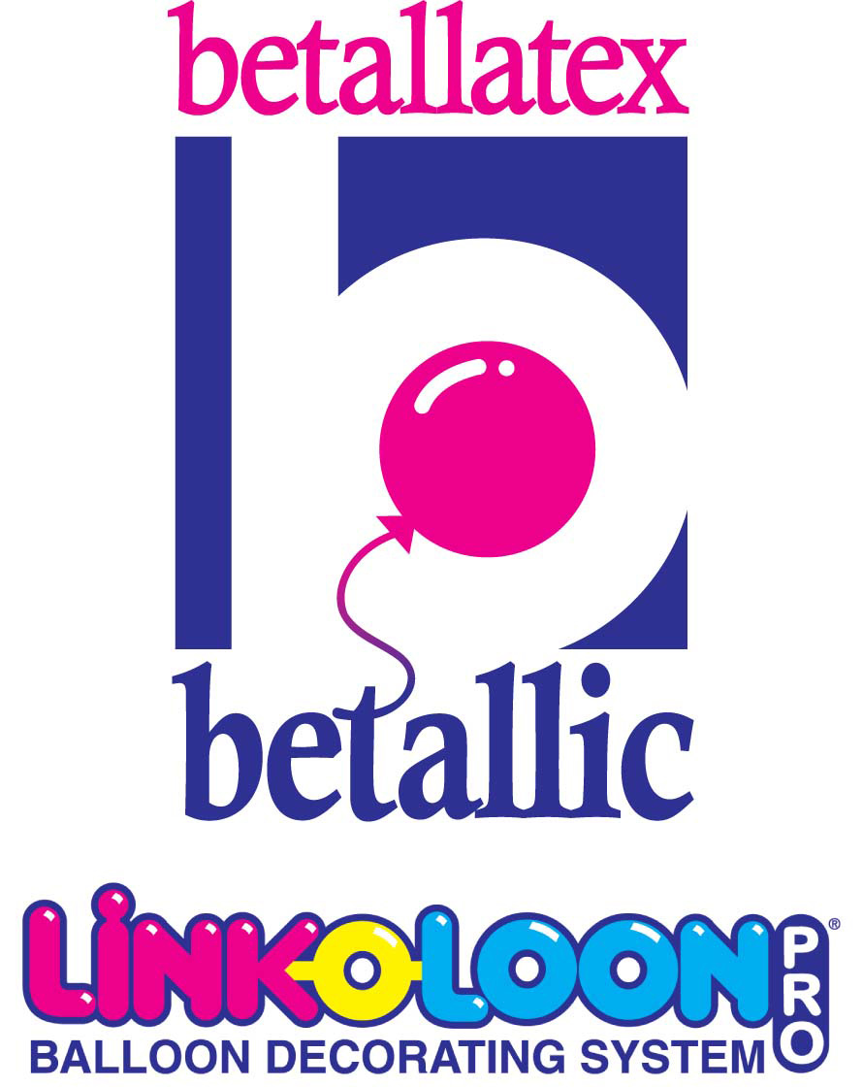

Long Lasting
Since balloons are air or nitrogen filled, the appearance of your designs will last and last. You’ll find crystals oxidize fairly quickly and pearls and metallics retain their fresh appearance the longest.

Inexpensive
More air/less helium balloon design affords a big visual impact and many times can fill the space with fewer balloons than helium. Air filled balloons can be prepared days ahead of time which decreases your labor costs.
Professional Results
Precision execution and fine detail are relatively easy to achieve with a minimum effort and the right equipment and tools. Use air-filled balloons, and you’ll look like a pro even in locations that don’t allow helium.

Simple to Sell
This system of balloon art appeals to every budget and every occasion. Its high visual impact allows you to create work you’re proud of and that customers will love for its beauty.

HERE ARE A FEW GUIDELINES TO INSURE YOUR SUCCESS:

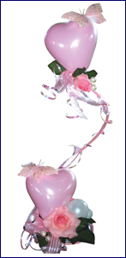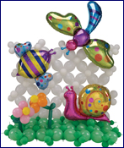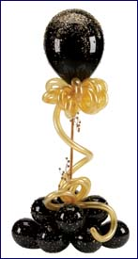
bdecor #169 bdecor #298 bdecor #224

PRODUCTS
  - Betallatex rounds come in a variety of sizes and types appropriate to the setting and longevity required for the job. Beautiful with air, helium or in combination.
  - Betallatex 60 Series non-rounds. 160, 260, 360 and 660s are positively amazing looking when used as air filled accessories throughout décor.
  - LINK-O-LOON® works beautifully for air filled décor in free standing columns that don’t require a frame, in long lasting ceiling treatments and air filled canopies. They also work in centerpieces, and in a variety of backdrops.
  - Betallatex latex hearts are fabulous as accents and amazing when used as backdrop elements directly adhered to walls as shown in class..
  - Betallic Foils can be air filled and used in creative ways to express a theme or occasion.
Register for FREE at www.betallic.com to view all bdecor design instructions..

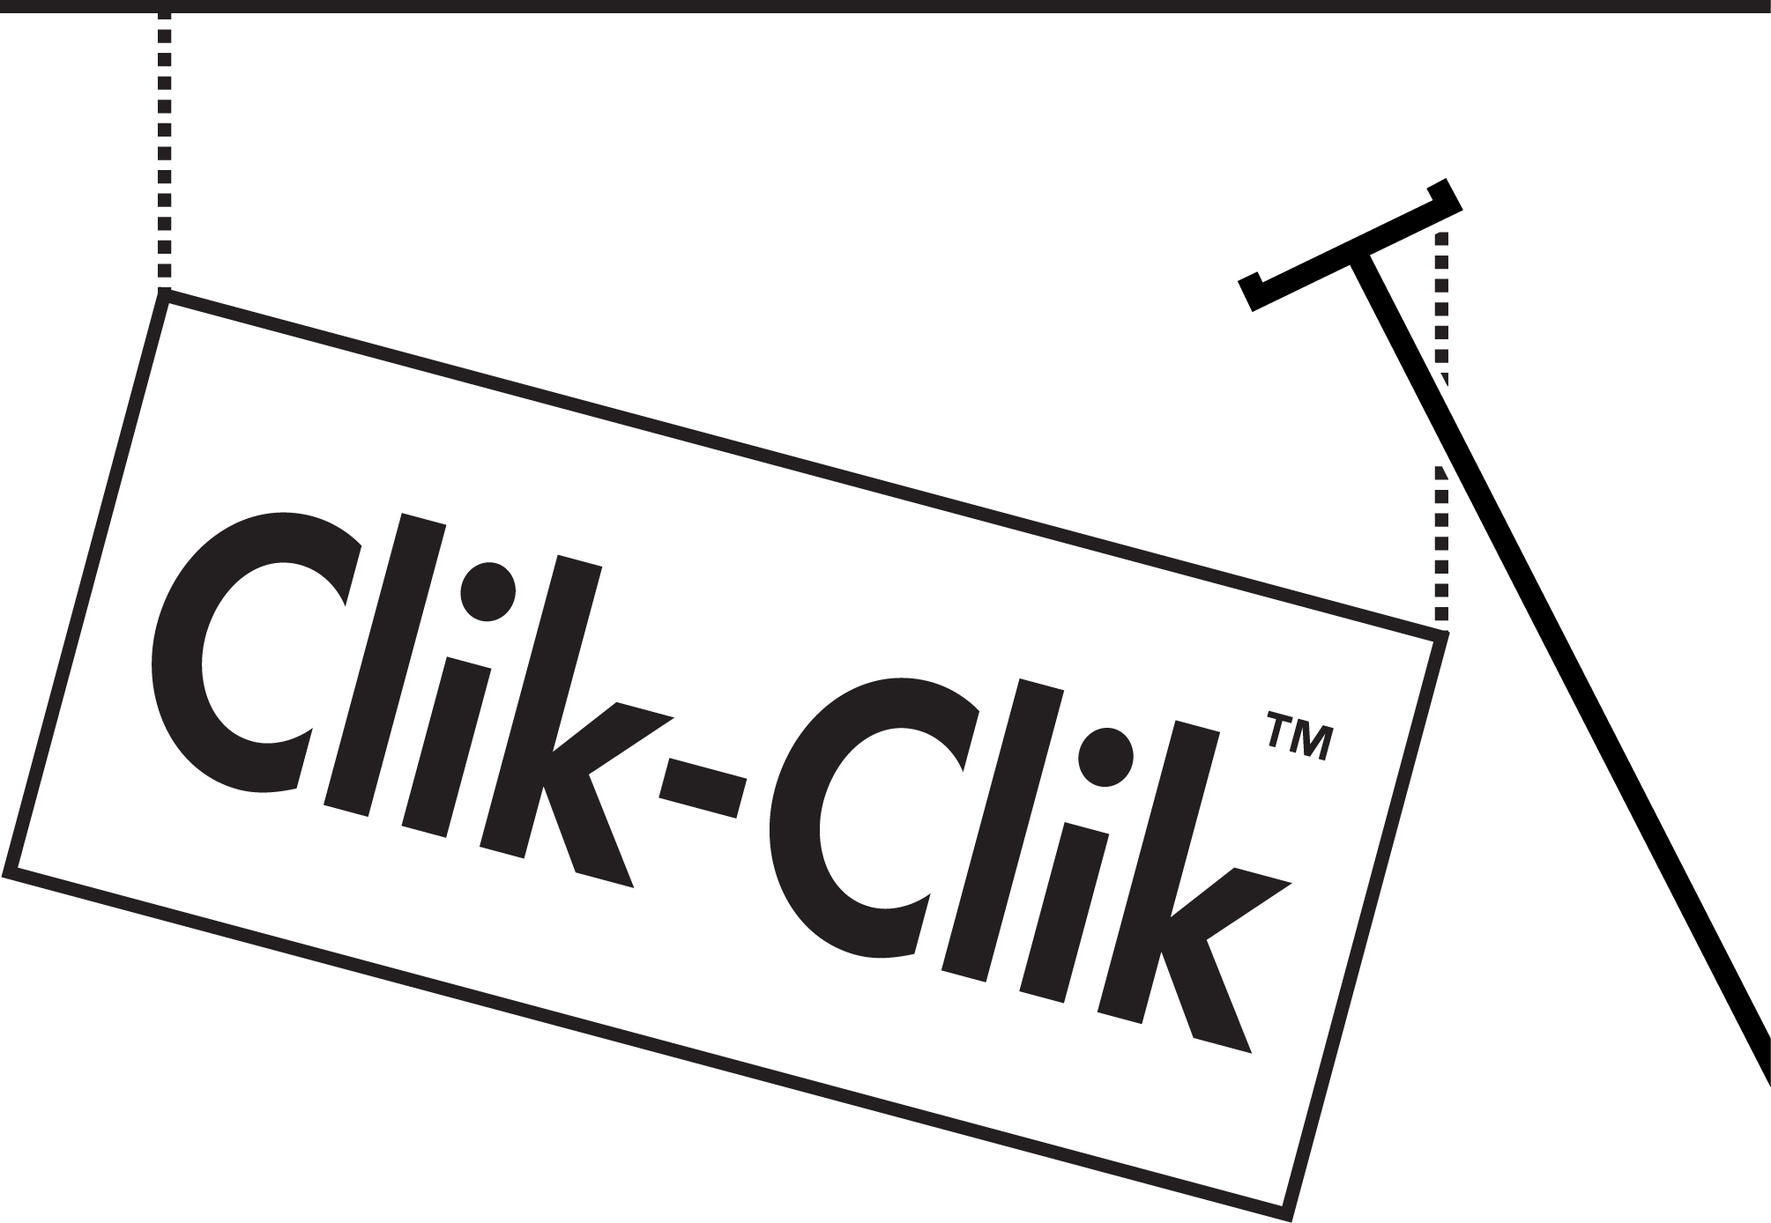
www.conwinonline.com www.magmover.com www.hi-float.com

TOOLS AND EQUIPMENT:
  - Professional Equipment that automatically sizes and, easy to use templates will insure your work looks precise every time for smooth, perfect lines throughout your designs. My favorite precision inflators? Conwin Precision Air or Dual Split Second Sizer which works with helium and Nitrogen or an air compressor.
  - When treating balloons with Ultra HI-FLOAT, always, always, always use the proper measurement. Guess work will be inconsistent and so will the performance of your work.
  - Don’t float--fly! It’s easy to look lighter than air with Clik Clik O-Ring Magnets and a MagMover system to “clik” air filled decor to metal rig points to appear to float in thin air!

HELIUM AND AIR???
  - 60/40 techniques are easier and more precise with Conwin 60/40 inflators that automatically and precisely fill to that exact percentage.
  - Today, you can even treat 60/40 11 inch balloons. This saves in product costs and is a perfect alternative when you need a longer window of performance than without treatment. This works well when a shorter float time can be effective. Be careful of adding too much ribbon since it can keep balloons from floating.
  - Nitrogen or Air? Both work very well. Nitrogen with a precision sizer is fast and easy and simply requires transportation of tanks. Air is provided by an electric air inflator like a Mini Cool Air which requires a sizing template for consistent appearance or an automatic air precision sizer.
ACCESSORIZE!





  - Accent materials are important to create a finished look for occasions like weddings. Tulle, silk blossoms, strands of pearls, props, and ribbon accents will add polish and harmony to an already strong design. Best of all, designs that use more air and less helium support these attractive accents more securely.
  - Creating the illusion of movement within a stationary display is not difficult. Wide ribbon tails trailing and curling within a design will add a dash of rhythm and motion and make a design appear more interesting.
  - Become best friends with the Principles and Elements of Design to insure though mostly air filled, your balloon designs will have a lighter-than-air appearance with the placement and sizing of the balloons and color use within the designs.

Last, don’t forget to bring your camera to your job site so more customers can see this wonderful décor option. If they see it, you’ll sell it!

Jan Iiams, CBA
Betallic Education Director

